Leveraging Federated Learning for Robust Load Balancing and Fault Tolerant Cloud Infrastructure
¹Shubham Kumar, ²Isha Pathak Tripathi, and ^{3*}Atul Tripathi
¹Department of CS & IT,
Mahatma Gandhi Central University,
Bihar, India
²Department of CSE,
Indian Institute of Information Technology,
Kota, India
^{*3}USAR,
Guru Gobind Singh Indraprastha Univeristy,
Delhi, India.
* atultripathiphd25@gmail.com

Abstract: In the face of intense competition from large domestic and international public cloud providers, the survival of small and medium-sized cloud vendors has become increasingly challenging. To address this, forming a cloud federation based on mutual cooperation has emerged as a viable strategy for these vendors. However, there exists a complex gametheoretic relationship between pursuing individual maximum benefits and ensuring the overall quality of service (QoS) within the federation. To tackle these issues, a QoS-based cloud federation model is proposed, encompassing the threelayer architecture of cloud computing. From the application layer to the virtual layer, an innovative Task allocation strategy based on the differential evolution (DE) algorithm is introduced, specifically designed to address multi-QoS Task allocation problems. From the virtual layer to the physical layer, a virtual machine migration model incorporating both cooperative and competitive dynamics is developed, aimed at balancing energy consumption and QoS in a cloud federation gametheoretic environment. Experimental results demonstrate that the proposed solution improves service quality in cloud computing environments and highlights the relative advantages of cooperation and competition within a cloud federation

context.

Keywords: small and medium-sized cloud vendors; gametheoretic environment; cloud computing; cloud federation; QoS.

Introduction
The advancement of Industry 4.0 hinges on the seamless integration of the physical and virtual worlds, with cloud computing serving as a cornerstone for network virtualization. At its core, cloud computing relies on an extensive server infrastructure to deliver virtualized services to users over the network, establishing itself as a transformative business model. This model offers nearly unlimited capabilities and services on a scalable, pay-asyou-go basis. By providing a dynamic pool of virtualized computing resources via the network, cloud computing unifies distributed resources from various organizations and individuals. Users can effortlessly access diverse computing environments through network connectivity without needing to manage resource allocation or deployment intricacies (1).
Virtualization, a fundamental concept in cloud computing, abstracts physical infrastructure to provide virtual resources, known as virtual machines (VMs), to facilitate sophisticated applications. In cloud computing, virtualization is essential since it consolidates computing resources from server clusters and dynamically assigns virtual machines to servers according to job demands. For each task execution request, a new virtual machine may be instantiated, or the task may be allocated to an existing virtual machine associated with the same user(2).
The development of cloud computing, along with its widespread adoption and application, has led to significant growth in both the number and size of cloud data centers(3). However, this growth has introduced challenges, particularly in terms of high energy consumption. Cloud data centers account for approximately 1.1% ∼ 1.5% of global electricity consumption, making them energy-intensive entities. This trend has a substantial impact on global energy demands, necessitating thorough analysis. Widely cited data indicates that global energy usage by cloud data centers has doubled in the past decade (4). Consequently, addressing energy consumption in cloud data centers has become a pressing issue of considerable interest (5).
In addition to energy consumption, another key factor directly affecting users in cloud computing is the quality of service (QoS). Today, cloud systems must meet the QoS requirements of each user and application when delivering services. Therefore, users or applications must explicitly specify their QoS needs when requesting services from cloud resources. Furthermore, the degree to which QoS requirements are met is a critical metric for evaluating the effectiveness of task scheduling strategies in cloud environments (6). As a result, task scheduling strategies in cloud systems typically consider specific QoS objectives and the performance metrics of available resources to ensure that numerous application tasks can be efficiently matched with the available computing resources (7, 8). A ServiceLevel Agreement (SLA) is the foundational contract between a cloud service provider (CSP) and the user. It specifies the expected QoS to be provided to the user, thereby quantifying user expectations. The SLA outlines key metrics such as throughput, reliability, blocking probability, and response time, as well as details about payment processes and penalties for SLA violations. Given the critical role of SLAs in ensuring user satisfaction and system performance, the research on dynamic scheduling of virtual machine resources has garnered significant attention. The objective of this research is to reduce system resource overutilization while meeting the specified SLA standards, thereby delivering more efficient and stable services to users (9).
Although cloud computing has brought substantial growth opportunities to users and enterprises, smalland medium-sized providers face significant challenges and competitive pressure from large, market-dominating cloud service providers (10). To overcome this predicament, companies have adopted an effective strategy of forming cooperative relationships, pooling resources from multiple small- and medium-sized providers to establish a robust resource consortium known as a cloud federation. Cloud federations offer small- and medium-sized providers a viable means to achieve sustainable development in the highly competitive cloud computing market (11). The issue of QoS management in cloud computing environments has become increasingly prominent. This problem encompasses a threelayer architecture, spanning from the user end (application layer) to the virtual end (virtual layer) and then to the physical end (physical layer). It involves two critical models: the taskresource allocation model and the virtual-resource allocation model. The three-layer resource model of cloud computing is illustrated in Figure 1.
In the three-layer resource model of cloud computing, the physical layer forms the foundation and comprises data centers housing a variety of hardware resources, including host servers. Positioned above the physical layer, the virtual layer leverages virtualization technology to partition physical hosts into virtual hosts, enabling more efficient and flexible resource management. At the top, the application layer delivers a broad spectrum of services to users, categorized into Software as a Service (SaaS), Platform as a Service (PaaS), and Infrastructure as a Service (IaaS), catering to diverse computing and business needs.
The cloud computing model is categorized into two parts from a service standpoint. The Task allocation management module offers users an economical approach to distributing virtual resources. The second component is the virtual resource scheduling module, which creates a correlation between physical resources and virtual machines. This study posits that each host supplies a minimum of one virtual machine.
This study delves into the mechanisms of Task allocation in virtual machine management and how these tasks subsequently migrate to the physical resource layer. The research provides cloud service providers (CSPs) with flexibility in participating in resource sharing. At the same time, different CSPs within a cloud federation can act as both collaborators and competitors.
Building on the models of cloud federations discussed in the literature(12–15), this study aims to explore new avenues of cooperation for small- and medium-scale CSPs. For instance, in scenarios with significant fluctuations in resource demand (e.g., during network traffic peaks), CSPs with sufficient resource reserves are more inclined to adopt a collaborative approach, offering surplus resources to partners. Conversely, when resources are limited, CSPs prioritize meeting the demands of their own users. The main contribution of this work is as follow:
- The proposed research introduces a comprehensive approach to addressing the challenges of load balancing and fault tolerance in cloud computing environments through a federation learning model.
- Development of a QoS-based cloud federation model encompassing a three-layer architecture to optimize resource allocation from the application layer to the physical layer.
- Introduction of an innovative Task Allocation strategy leveraging the Differential Evolution (DE) algorithm, specifically addressing multi-QoS task allocation problems.
- Formulation of a virtual machine migration model incorporating cooperative and competitive dynamics to balance energy consumption and QoS in a gametheoretic cloud federation context.
The remainder of this paper is organized as follows. Section 2 reviews related work, focusing on existing approaches to task scheduling, virtual machine migration, and resource optimization in cloud computing. Section 3 presents the system model, detailing the proposed QoS-based task allocation strategy and virtual machine migration model, including their theoretical underpinnings and algorithmic implementation. In Section 4, a fault-tolerant scheduling algorithm is introduced to enhance resource utilization and reliability in the cloud environment. Section 5 describes the experimental setup and provides a comprehensive evaluation of the proposed strategies, comparing them to conventional approaches in terms of execution time, cost, and energy consumption. Finally, Section 6 concludes the paper, summarizing the contributions and outlining potential future research directions, such as integrating network conditions and validating the model on alternative platforms like OpenStack.
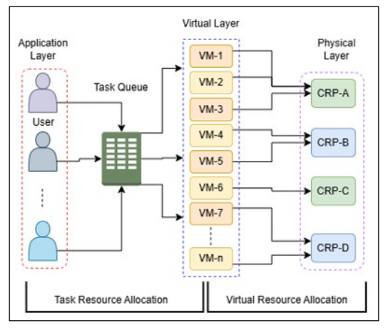
Fig. 1. Robustness Testing on Imbalanced Datasets

Related Works
Researchers have extensively explored task scheduling and resource management in cloud computing to optimize performance and resource utilization.

Task Scheduling
Task scheduling in cloud computing entails aligning workloads with differing requirements to computing resources with varied specifications, rendering it a non-deterministic polynomial (NP) problem. To tackle this difficulty, various heuristic methods have been devised to approximate optimal solutions. Traditional methodologies like the Min-Min approach (16) and Max-Min approach (17) serve as prevalent benchmarks for assessing alternative scheduling algorithms. These methodologies, while analogous, are essential in directing the formulation of task scheduling techniques.
For more complex scheduling problems, researchers have adopted intelligent optimization algorithms. For instance, genetic algorithms have been applied to real scientific workflows to approximate global optimal solutions (18). For computation-intensive tasks, Nooriantalouki et al. (19) proposed a scheduling method for handling both independent tasks and task queues on heterogeneous platforms.

Advanced Scheduling Models:
- Hybrid Game-Theoretic Models: Li et al. (20) introduced a hybrid game-theoretic model focusing on task type preferences and resource capabilities. They used a multi-service evolutionary game-theoretic scheduling algorithm to optimize Quality of Service (QoS).
- Budget-Constrained Scheduling: Tang et al. (21) developed a scheduler for handling multiple task queues under various constraints, such as minimum completion time and maximum budget, addressing performance parameters effectively.

Virtual Machine Migration
Virtual machine (VM) migration serves as a critical form of resource allocation, ensuring optimal resource utilization and energy efficiency.
- Fuzzy Soft Set-Based Algorithms: Baskaran et al. (22) proposed a fuzzy soft set virtual machine (FSSVM) consolidation algorithm, tested with 11 selection parameter combinations to enhance QoS.
- Sine Cosine Algorithm (SCA) and Ant Lion Optimizer (ALO): Gharehpasha and Masdari (23) integrated memory utilization considerations into VM migration, using a discrete multi-objective approach for optimal VM allocation, leading to idle node shutdowns after consolidation.
- Minimizing Migrations: Padmavathy et al. (24) focused on reducing the number of migrations, developing a consolidation model to minimize computing nodes and VM migration time.

Breakthrough Optimization Techniques
Conventional VM migration research has been significantly advanced by Verma (25), who introduced the dualcondition moth-flame algorithm (DC-MFA). This innovative approach optimizes multiple objectives, including CPU utilization, energy consumption, security, makespan, migration cost, and resource cost, establishing a new benchmark in VM migration optimization.

System Model
This section explores the design details of the Task allocation model in depth. First, the Task allocation module is comprehensively formalized with QoS equations, laying the foundation for subsequent explanations. Building on this, the architecture of the Task allocation process is described in detail, designed to mimic its core algorithmic design. Finally, the binding policy based on differential evolution (BPDE) is introduced, which serves as a key component supporting the implementation of Task allocation during the process.

QoS Formula for Task Allocation Module
Quality of Service (QoS) in cloud services is determined using various attributes, as outlined in Table 1. Table 2 provides the meanings of the symbols utilized in the proposed model.
This paper presents a novel task scheduling approach, Task Scheduling based on Multiple QoS (TS-M-QoS), which addresses the task allocation challenge. The TS-M-QoS is built upon three core QoS objectives: scheduling deadline, scheduling budget, and a composite parameter capturing the reliability, availability, and security performance.
The scheduling deadline establishes the maximum duration permitted for job execution across all virtual machines, whereas the scheduling budget delineates the overall expenditure for task completion inside the cloud environment. Reliability, availability, and security are essential differentiators among cloud service providers (CSPs), affecting user choices.
In the cloud environment, virtual resources are represented as a set of virtual machines, V M = {m|m ∈ 1,...,M}, where M is the total number of VMs. Similarly, the set of tasks awaiting scheduling is denoted as T = {n|n ∈ 1,...,N}, where N is the total number of tasks.
The model aims to optimize execution time and cost, constrained by deadline and budget. The multi-objective optimization model is defined as:
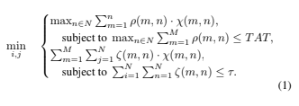
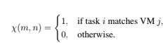
Here, TAT represents the execution deadline, τ is the total budget, ρ(m,n) is the execution time for task T_{i} on VM j, and ζ(m,n) is the associated cost. The fitness function for task mapping is given as:
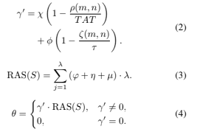
The architecture of TS-M-QoS, depicted in Figure 2, illustrates the Task allocation process.
- Step 1: Users submit tasks and QoS requirements to the task scheduler, while VMs provide resource information.
- Step 2: The scheduler generates simulation results based on the BPDE strategy.
- Step 3: The scheduler evaluates the simulation results.
- Step 4: If the VM meets the task requirements, the task is assigned; otherwise, the user is informed of the rejection.
- Step 5: The VM executes the allocated task.

DE-Based Binding Strategy
Task scheduling in cloud computing systems is an NPhard problem, as previously stated. In scenarios with numerous people, identifying the ideal approach becomes challenging. The prevalent method involves utilizing diverse intelligent optimization algorithms to approximate the ideal answer, which functions as an adequate resolution. The Differential Evolution (DE) algorithm (26) is utilized to derive an approximation optimal solution. The DE algorithm is modified to meet the model specifications for task-toVM allocation. The primary parameters established comprise population size (NP), the mutation control parameter (f), and the crossover probability (CR). The precise steps are as follows:
Table 1. QoS Attributes
Attribute Name | Meaning
Execution Cost (ζ) | Cost incurred by the CSP to execute a task.
Execution Time (ρ) | Time required by the CSP to execute a task.
Reliability (φ) | Probability of the cloud service functioning normally.
Availability (η) | Likelihood of successful access to the cloud service.
Security (µ) | Security level offered by the cloud service.

Table 2. Meaning of Symbols
Symbol | Meaning
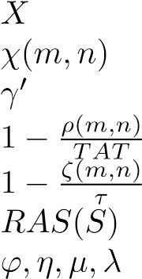 | Mapping between tasks and VMs post-scheduling.  Boolean value indicating task i matches VM j.  Impact vector of execution time and cost for task-VM mappings.  Time saved score for task execution.  Score related to cost saved upon task completion.  Composite reliability, availability, and security score for system X. Reliability, availability, security of VM j, and the number of tasks it executes.
θ | Fitness function representing the score of mapping X.
χ,ϕ | Weight factors for execution time and cost importance.

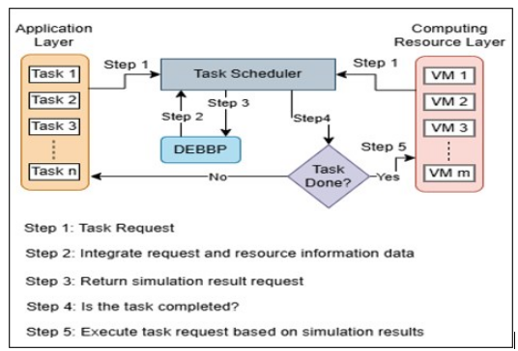
Fig. 2. TS-M-QoS Architecture for Task allocation

- Initial Population: A population σ is created, consisting of individuals σ_{ν}, where the components of each individual in different dimensions are represented as σ_{ν,w}, with k = 1,··· ,NP. The bounds for σ_{ν,w} are defined as σ_{ν,w}^{L} ⩽ σ_{ν,w} ⩽ σ_{ν,w}^{U} , k = 1,2,··· ,NP. Here, σ_{ν}(0) represents the k-th individual, and w denotes the w-th dimension. The initial values of individuals in each dimension are generated using Equation (5):
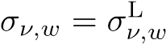+ rand(0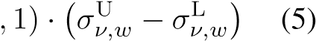
In this context, σ_{ν,w}^{L} and σ_{ν,w}^{U} represent the lower and upper bounds, respectively, for the w-th dimension. The term rand (0,1) denotes a random number uniformly distributed between 0 and 1. In the BPDE (Differential Evolution-Based Bipartite Problem) algorithm, an individual σ_{ν} represents a matching result between virtual machines (VMs) and tasks. Specifically, σ₁ corresponds to VM₁, and the value of σ₁ represents the task matched to VM₁. The set σ₁,σ₂,··· ,σ_{NP} denotes the matching results for NP VMs. Each dimension represents one matching result and corresponds to a specific f(−).
- Mutation: The DE algorithm executes mutation via a differential method. A frequently employed technique entails the random selection of two distinct people, σ_{r2} and σ_{r3}, from the population. A scaling factor
f is subsequently applied to the difference between σ_{r2} and σ_{r3}. The scaled difference is combined with another randomly chosen individual σ_{r1} to produce the mutation vector V ^{g}_{i}⁺¹:
V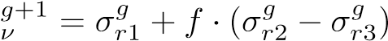 (6)
Here, r1, r2, and r3 are three random integers selected from the range [1,NP], where f is a predefined constant, and g represents the g-th generation.
- Crossover: The objective of the crossover operation is to randomly choose persons. The procedure for doing the crossover operation is delineated as follows:
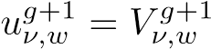, if rand(0,1) ⩽ CR, j = 1,··· ,D,
u^{g}_{ν,w}⁺¹ = x^{g}_{ν,w}, if rand(0,1) > CR, j = 1,··· ,D, (7)
Here, CR represents the crossover probability. The crossover operation is part of the optimization process. If 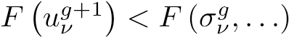, it indicates that the new generation (g + 1) is better than the previous generation (g). In this case, σ_{ν,n}^{g} = u^{g}_{ν,w}⁺¹. Here, F(−) is the fitness function described in Equation (4).

Algorithm 1 Pseudocode for Applying DE
Require: Population size NP, Mutation control parameter f, Crossover probability CR, Fitness function F(σ), Initial population σ_{G}^{k} , Number of iterations
Ensure: The optimal solution (task scheduling result)
1: Initialize t ← 0
2: while t ≤ max iterations do
3: for each σ^{k}_{G} in population σ do
4: Generate mutation vector v^{i,k}_{G} using Equation (6)
5: Perform vector crossover using Equation (7)
6: if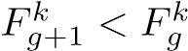then
7: Update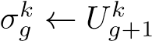
8: end if
9: end for
10: Increment t ← t + 1
11: end while
12: return the individual with the best fitness in the final generation

Fault-Tolerant Scheduling Algorithm
This section designs a fault-tolerant scheduling algorithm (FSVC) for virtualized cloud platforms. The algorithm leverages backup version overlap and virtual machine migration techniques to improve resource utilization while meeting fault tolerance requirements. When a new task arrives in the cloud, the system first schedules the primary version and then schedules the backup version. If either the primary or backup version is rejected, the task will be rejected.

Primary Version Scheduling Algorithm
To leave sufficient time margins for the backup versions, the primary version should be completed as early as possible. Additionally, based on Theorem 1, the fundamental premise for two backup versions to overlap is that their primary versions are not on the same host. Therefore, primary versions cannot be concentrated on several hosts, as this would make overlapping of backup versions infeasible and reduce resource utilization. Hence, the scheduling of primary versions must achieve the following two objectives. 1) The completion time of the primary version should be as early as possible.
2) The primary versions should be evenly scheduled across all active hosts.
One significant difference between cloud computing and traditional computing models is that tasks are scheduled on virtual machines rather than on hosts. However, to achieve the two objectives mentioned above, the state of the hosts must also be considered during scheduling. To this end, this paper proposes a two-phase strategy.
First, determine the set of candidate hosts. Hosts with a smaller number of primary versions are selected as candidate hosts. In the proposed algorithm, the top α% of hosts with the fewest primary versions are chosen as candidate hosts. Next, select the virtual machine allocated to the primary version. From all virtual machines on the candidate hosts, choose one virtual machine where the completion time of the primary version is the earliest.
Through this strategy, the primary versions of newly arrived tasks will be prioritized for scheduling on hosts with fewer primary versions to achieve uniform distribution of the primary versions. A smaller α results in a more even distribution of primary versions, but if α is too small, it may lead to a limited number of available virtual machines, delaying the start time of the primary version. An appropriate α can strike a balance between the early completion of primary versions and uniform distribution.
If none of the existing virtual machines can accommodate the primary version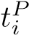, a new virtual machine can be created. The processing capability of the new virtual machine P_{new} must satisfy the following equation:
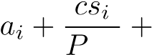 delay = d_{i} (8)
new
Where delay represents the time reserved for starting a host and creating a virtual machine. The algorithm presented in this paper first attempts to place the new virtual machine on an active host. If no suitable active host is available, it performs virtual machine migration to consolidate existing virtual machines and free up host resources for the new virtual machine. If there are still no suitable active hosts, a host will be started from the powered-off hosts H − H_{a}, and the new virtual machine will be placed on the newly activated host. Algorithm 1 provides the pseudocode for scheduling the primary version in FSVC.
In Algorithm 2, virtual machine migration technology is incorporated to improve resource utilization. A two-phase strategy is employed again to ensure that while integrating virtual machines through migration, the distribution of primary versions becomes more uniform, and the impact on already scheduled versions is minimized as much as possible. First, select a host with the highest number of primary versions. Migrate the virtual machines on that host to reduce the number of primary versions. Next, choose the virtual machine with the fewest primary versions on that host for migration, thereby minimizing the impact on already scheduled versions. The pseudocode for virtual machine migration is shown in Algorithm 3.
Next, we analyze the time complexity of the primary version scheduling algorithm. Let N_{a} denote the total number of active hosts in the cloud platform, N_{vm} denote the maximum number of virtual machines on each active host, and N_{tw} denote the maximum number of tasks waiting to execute across all virtual machines. To determine a suitable virtual machine within the existing resources, the time complexity of lines 1) to 21) in Algorithm 1 in the best case (i.e., finding a suitable virtual machine in the first group of candidate hosts) is O(αN_{a}N_{vm}N_{tw}), while in the worst case (i.e., scanning all active hosts), it is O (N_{a}N_{vm}N_{tw}). The time complexity of the function vmMigration(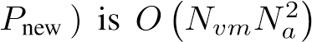, thus the time complexity of adding a new virtual machine in lines 22) to 50) is.
Therefore, in the best case, the time complexity of the primary version scheduling algorithm is O(αN_{a}N_{vm}N_{tw}), while in the worst case, it is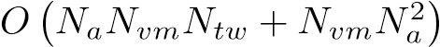. It is worth noting that, typically, it is unnecessary to scan all hosts or add resources. Consequently, it can be observed that with the introduction of a two-stage strategy, this algorithm can achieve a more uniform distribution of primary versions while also reducing the algorithm’s complexity.

Secondary Version Scheduling Algorithm
Before designing the algorithm, we first introduce a concept described in reference [11], known as the copy cost:
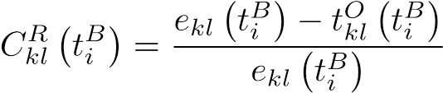 (9)
where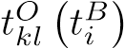 denotes the computation time during which 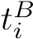 overlaps with other secondary versions on virtual machine v_{kl}. The copy cost represents the ratio of the computation time occupied by this secondary version, excluding the overlapping portion, to the execution time. A low copy cost indicates that, apart from the overlapping section, this secondary version requires relatively little computation time. In other words, the actual resource consumption is minimal.
Algorithm 2 Pseudocode for Primary Version Scheduling
Require: Set of hosts H_{a}, Task 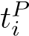with deadline d_{i}, Parameter α, Processing power P_{new}, Function vmMigration
Ensure: Assignment of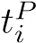 to a virtual machine or rejection
1: Sort H_{a} in ascending order by the count of scheduled primary versions
2: Hcandidate ← top α% hosts in Ha
3: find ← FALSE; EFT ← +∞; v ← NULL
4: while not all hosts in H_{a} have been scanned do
5: for each hk in Hcandidate do
6: for each v_{kl} in h_{k}.VmList do
7: Calculate the earliest finish time EFT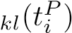
8: if EFT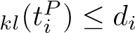 then
9: find ← TRUE
10: if EFT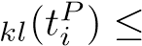 EFT then
11: EFT ← EFT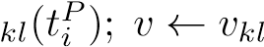
12: end if
13: end if
14: end for
15: end for
16: if find == FALSE then
17: H_{candidate} ← next top α% hosts in H_{a}
18: else
19: break
20: end if
21: end while
22: if find == FALSE then
23: Create newVm with processing power P_{new}
24: for each h_{k} in H_{a} do
25: if h_{k} can accommodate newVm then
26: Allocate newVm to h_{k}
27: v ← newVm; find ← TRUE
28: break
29: end if
30: end for
31: if find == FALSE then
32: sourceHost ← vmMigration(P_{new})
33: if sourceHost ̸= NULL then
34: Allocate newVm to sourceHost
35: v ← newVm; find ← TRUE
36: end if
37: end if
38: end if
39: if find == FALSE then
40: Turn on a new host h_{new} from H − H_{a}
41: if MIPS of h_{new} satisfies P_{new} then
42: Allocate newVm to h_{new}
43: v ← newVm; find ← TRUE
44: end if
45: end if
46: if find == TRUE then
47: Allocate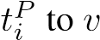
48: else
49: Reject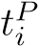
50: end if

Algorithm 3 Pseudocode for vmMigration Function
Require: New processing power requirement P_{new}
Ensure: The source host sourceHost for VM migration Sort H_{a} in decreasing order by the count of scheduled primaries
Initialize sourceHost ← NULL
3: for each host h_{i} ∈ H_{a} do
Sort h_{i}.vmList in increasing order by the number of scheduled primaries
Initialize currentPower ← 0; migrationList ← ∅
6: for each VM v_{j} ∈ h_{i}.vmList do for each host h_{k} ∈ reversed(H_{a}) do
if v_{j} can be migrated to h_{k} and h_{k} satisfies VM constraints then
9: currentPower ← currentPower + v_{j}.power
Add {v_{j},h_{k}} to migrationList break
12: end if end for if currentPower ≥ P_{new} then
15: break end if
end for
18: if currentPower ≥ P_{new} then
Set sourceHost ← h_{i}
Execute migrations in migrationList
21: break end if
end for
24: return sourceHost

To improve resource utilization, two objectives must be achieved when scheduling secondary versions: 1) Secondary versions should adopt the passive mode as much as possible. 2) The copy cost of secondary versions should be minimized. Based on these two objectives, this algorithm employs the ALAP strategy to minimize the copy cost of secondary versions while ensuring the latest possible start time for the secondary versions. Algorithm 4 presents the pseudocode for scheduling secondary versions in FSVC.

Virtual Machine Migration Model
Virtual machine migration typically occurs between the physical and virtual resource layers. The virtual resource layer, positioned above the physical layer, serves as the operational platform for the application layer, functioning as a virtual server. This layer can host multiple applications within a single virtual machine, creating a many-to-one relationship between applications and virtual machines.
The physical resource layer, consisting of various hardware servers within the data center, provides the necessary resources to the virtual resource layer. This layer also follows Algorithm 4 Pseudocode for Secondary Version Scheduling
Require: Set of hosts H_{a}, Task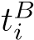 with deadline d_{i}, Current host of primary version host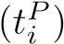

Ensure: Assignment of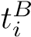 to a virtual machine or rejection
1: Sort H_{a} in increasing order by the remaining MIPS
2: Initialize find ← FALSE; LST ← +∞; C ←
+∞; v ← NULL
3: for each host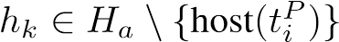do
4: for each virtual machine v_{kl} ∈ h_{k}.vmList do
5: Calculate the latest start time LST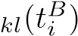
6: if LST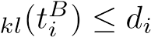 then
7: find ← TRUE
8: Calculate the replication cost cost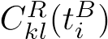
9: if 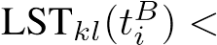 LST or LST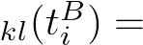
LST and then
10: Update LST ← LST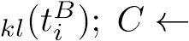
CklR(tBi )
11: Update v ← v_{kl}
12: end if
13: end if
14: end for
15: end for
16: if find = TRUE then
17: Proceed with similar steps to lines 22 to 50 in
Algorithm 2
18: else
19: Reject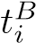
20: end if

a many-to-one mapping, where a single physical server can host multiple virtual machines.
Due to the evolving demands for application service access in the proposed architecture, a flexible cloud resource management platform is crucial. This platform must be able to modify the quantity of virtual machines to accommodate varying service demands. Scalability is essential, as it enables numerous migrations of virtual machines across hosts, influencing the overall usage of physical servers, the equilibrium of resource distribution, and the energy consumption of the data center.

Cloud Federation Model
In the field of cloud federation, cooperation models typically exhibit different cloud service providers (CSPs) working in harmony. First, they share resources, but each service provider maintains a clear and independent entity identity and upholds clear boundaries between each other. Second, the applications running within this large cloud federation are unaware of each other’s specific locations, which is achieved through a virtual local area network (VLAN) that facilitates communication between different application components. Finally, these cloud service providers differentiate themselves based on factors such as their own costs and trust levels.
Cloud computing allows virtual machines allocated to user tasks to have different migration paths. These machines can locate themselves within the physical resources of the user’s current CSP or within the physical resources of other CSPs. The flexibility of allocating virtual resources to physical domains leads to two possible scenarios: one is a cooperative model, where a user’s virtual machines can freely migrate to any location; the other is a competitive model, where these virtual machines are restricted to migrating within the physical infrastructure of the original CSP. The cloud federation resource management framework is shown in Figure 3.
In the proposed model, the available resources of PM_{ν} in CSP_{x} are represented by R_{pn} (ν_{x}), and the resource demand of VM_{j} during migration is represented by D_{1n} (n_{y}). The cloud federation problem involves finding a mapping of each VM_{j} in the waiting queue to physical resources PM_{ν}, which maximizes the utility function D(n,ν) in Equation (8): maxD(m,ν) = P (n_{y},ν_{x})(R_{pn}(ν) − D_{1n}(n)), comprehensively ranked and chosen as migration targets.
- Dirty Page Tracking: When virtual machine migration begins, the virtual machine enters an inactive state until the process is completed. During migration, its memory is transferred iteratively from the source (hot node) to the target (destination compute node). In each iteration, only the modified memory pages, known as ”dirty pages,” are transmitted. Once the final iteration is reached, the hot node halts the virtual machine’s operation and transfers the remaining ”dirty pages” to the destination. This process is managed using dirty page tracking mechanisms, which efficiently handle the conversion and transmission of these modified pages.
R_{pn}(j) ⩾ D_{vn}(ν) ∀n ∈ V,ν ∈ P; ∀n ∈ V,ν ∈ P → P (n_{y},ν_{x}) ∈ {0,1},
- Target Node PM Selection: DSA determines the matching method based on the differences in resources between the virtual machine’s requirements and all candidate physical nodes. The CPU and memory

(10) In this context, P (n_{y},ν_{x}) is a binary parameter used in the model to distinguish between cooperative and competitive cloud computing, as shown in Equation (9).

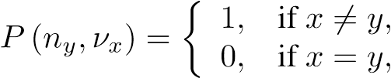
cooperative cloud federation, competitive cloud federation. (11)

Dynamic Scheduling Algorithm
To support virtual machine migration in the cooperative and competitive cloud environments described above, the model proposed in this paper introduces a dynamic scheduling algorithm (DSA) based on the necessity of virtual machine migration. This is achieved through a dynamic cloud resource scheduling model and the use of virtual machine migration technologies discussed in the literature (27).
The algorithm considers the load on physical nodes, evaluates the potential losses caused by virtual machine migration, and strategically identifies target hosts. The main goal is to ensure efficient load balancing through effective resource scheduling. The architecture of the DSA, based on migration technologies, is shown in Figure 4, and it can be divided into five steps:
- Hot Node Load Evaluation: Physical nodes PM with a load greater than the upper threshold or less than the lower threshold are defined as hot nodes.
- Migration Loss : DSA considers migration costs and does not aim to eliminate all hot nodes through VM migration. The goal is to select VMs with a low migration loss ratio as targets. Therefore, the VMs with the lowest CPU and memory usage are resource differences between the virtual machine to be migrated and all candidate physical machines are comprehensively ranked, with the physical machine having the largest difference selected as the target PM.
5. Complete Virtual Machine Migration and Migration Log Update: After the virtual machine migration is completed, the migration log is updated, ensuring the tracking and management of the migration process.

Experimental Results
The experimental environment is CloudSim, a toolkit developed jointly by the University of Melbourne and the Gridbus project for simulating cloud computing environments. It is written in Java and includes a complete cloud computing infrastructure, supporting the configuration of the number and parameters of tasks, virtual machines, and physical machines in cloud computing simulation experiments. It also supports custom Task allocation strategies and virtual machine migration strategies. The CloudSim simulation environment used in the experiment is as follows: the CPU is an Intel Pentium Dual-Core P6000 with a clock frequency of 1.87 GHz; the memory is 16.0 GB; the hard disk drive (HDD) is 1 TB.

Task allocation Management Model
The experiment utilizes eight compute nodes, each characterized by specific attribute parameters. These nodes are configured to emulate performance and computing capabilities modeled after the Amazon EC2 on-demand instance pricing framework. Table 3 presents the virtual machines used in the Task allocation management model, where MIPS indicates the CPU performance metric.
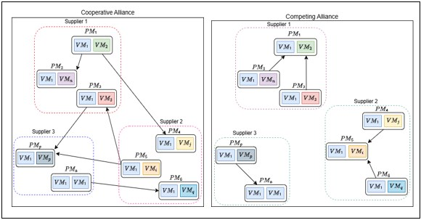
Fig. 3. Robustness Testing on Imbalanced Datasets
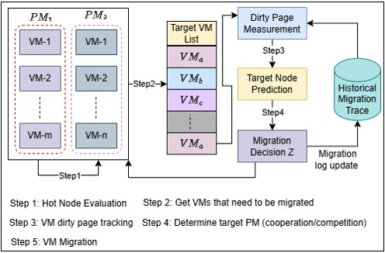
Fig. 4. Robustness Testing on Imbalanced Datasets

Table 3. Virtual Machines for the Task Allocation Management Model
Property | VM-0 | VM-1 | VM-2 | VM-3 | VM-4 | VM-5 | VM-6 | VM-7
MIPS | 101 | 410 | 213 | 54 | 55 | 363 | 70 | 118
Availability (Ava) | 40 | 10 | 20 | 20 | 30 | 50 | 10 | 30
Reliability (Rel) | 10 | 10 | 10 | 60 | 20 | 40 | 10 | 20
Security (Sec) | 20 | 40 | 10 | 40 | 10 | 60 | 50 | 30

The experiment simulated two tasks: Task P (Job P) and Task Q (Job Q), tested using three Task Qinding strategies: the BPDE strategy, the default CloudSim binding strategy (Conventional), and the Max-Min-based binding strategy.

These strategies are designed to allocate tasks (Cloudlets) to Virtual Machines (VMs). Each task consisted of 20 Cloudlets requiring VM allocation. The details of the Task allocation management model are summarized in Table 4.
For the simulations, the weight factors were set as χ = ϕ, with scheduling deadlines and budgets fixed at
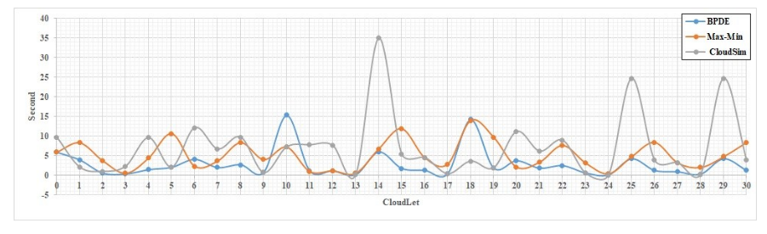
Fig. 5. Execution Time Job P

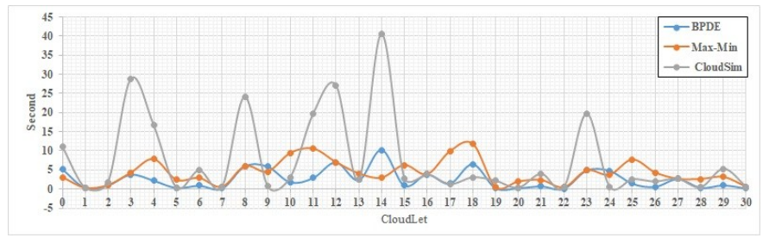
Fig. 6. Execution Time Job Q

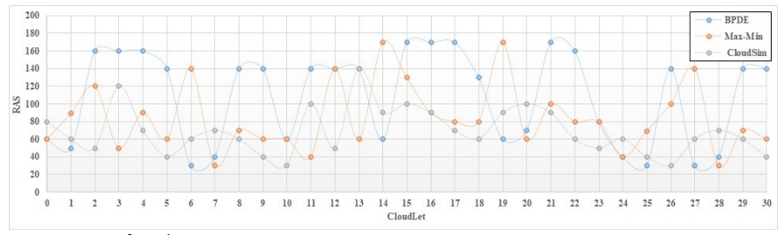
Fig. 7. RSA for Job P

100 and 1800, respectively. The Differential Evolution (DE) algorithm’s operational parameters were configured as follows: a population size of 100, mutation scaling factor of 0.5, crossover rate of 0.1, and maximum iterations capped at 2000. The value range for the algorithm was bounded between -8 and 8.
The simulation results for execution time for Job P and Job Q are presented figures 5 and 6 visualize the execution time and cost outcomes for both jobs, while the Resource Allocation Score (RAS) results are depicted in Figure 7- 8.
The experiment compared the performance of the BPDE binding strategy with the cloudsim and Max-Min binding strategies for each job in terms of total execution time, total execution cost, and Resource Allocation Score (RAS).
From Figures 5- 6, it can be observed that for both Job P and Job Q, the execution time of Cloudlets in BPDE is shorter
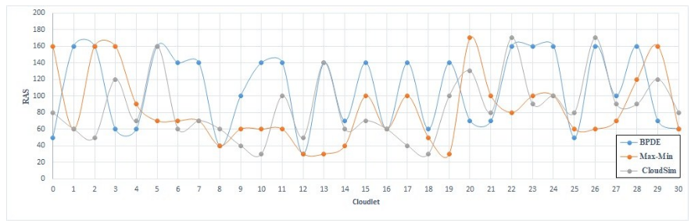
Fig. 8. RSA for Job Q

Table 4. Tasks of the Task Allocation Management Model
CloudletID | Job P | Job Q
a | 2040 | 950
b | 720 | 130
c | 190 | 330
d | 120 | 1320
e | 460 | 860
f | 640 | 140
g | 730 | 330
h | 680 | 80
i | 840 | 2240
j | 840 | 310
k | 1120 | 620
l | 320 | 840
m | 320 | 1170
n | 60 | 690
o | 1770 | 950
p | 480 | 280
q | 320 | 320
r | 130 | 430
s | 570 | 520
t | 920 | 110
than that of the cloudsim binding strategy and the Max-Min binding strategy:
- For Job P, the total execution time of BPDE is shorter by 68.61% compared to the Conventional binding strategy and by 8.97% compared to the Max-Min binding strategy.
- For Job Q, the total execution time of BPDE is shorter by 73.84% compared to the Conventional binding strategy and by 13.53% compared to the Max-Min binding strategy.

From Figures 7- 8, it can be seen that:
- For Job P, the total RAS of BPDE is higher by 47.06% and 43.31% compared to the Conventional and Max-

Min binding strategies, respectively.
- For Job Q, the total RAS of BPDE is higher by 44.44% and 39.87% compared to the Conventional and Max-

Min binding strategies, respectively.
The simulation results indicate that the Conventional binding strategy in CloudSim does not optimize QoS, resulting in much lower QoS performance compared to the other two binding strategies. Compared to Max-Min, BPDE demonstrates significant advantages due to its evolutionary strategy, which is better suited for resource allocation.

Implementation of DSA
The experiment set up four types of virtual hosts, each consisting of 30 different virtual machines. These virtual machines are characterized by MIPS, Pes, RAM, bandwidth, and storage.
For VM migration, the experiment set up four types of virtual hosts, each consisting of 30 different virtual machines. These virtual machines are characterized by attributes such as MIPS, Pes, RAM, bandwidth, and storage size. Additionally, the experiment defined four CSPs, each with 10 hosts. The hosts were configured with parameters such as MIPS, Pes, RAM, bandwidth, and storage size. The maximum/minimum load thresholds for the virtual hosts were defined as 80%/0. The experimental parameters for VM migration are shown in Table 8.
The study also discusses energy consumption and SLA violations during VM migration and examines two VM migration algorithms: ES-VSA (28) and ADT-EC (29). To validate the performance of DSA, the experiment compared three performance metrics of the aforementioned migration strategies, namely SLA, VM migration time, and energy consumption. The results are shown in Figures 9, 10, and 11, respectively.
Table 5. Experimental Parameters for VM Migration
Type Settings |  | Quantity | MIPS | Pes | RAM | Storage Size
VM Type | Type 1 | 20 | 500 | 1 | 870 | 2500
 | Type 2 | 20 | 1000 | 1 | 1740
 | Type 3 | 20 | 2000 | 1 | 1740
 | Type 4 | 20 | 2500 | 1 | 613
CSP1 | 10 Hosts of Type 1 | 25 | 1860 | 2 | 4096 | 1000000
CSP2 | 10 Hosts of Type 2 | 25 | 2660 | 2 | 4096
CSP3 | 10 Hosts of Type 3 | 25 | 2980 | 2 | 4096
CSP4 | 10 Hosts of Type 4 | 25 | 3220 | 2 | 4096

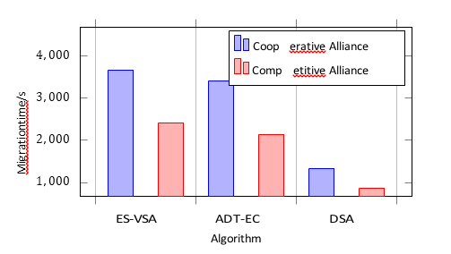
Fig. 9. Virtual machine migration time comparison

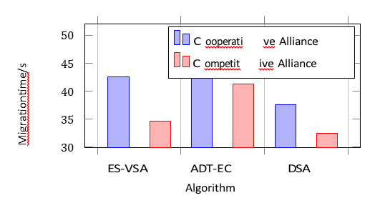
Fig. 10. Virtual machine migration energy consumption comparison

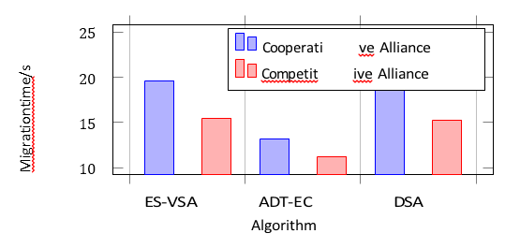
Fig. 11. Virtual machine migration SLA comparison

DSA aims to avoid unnecessary VM migrations, giving it a significant advantage in VM migration time within cooperative and competitive coalitions. As shown in Figure 8, it reduces migration time by 84.05% and 80.89% compared to ES-VSA and by 86.20% and 80.02% compared to ADTEC.
Furthermore, as illustrated in Figure 9, DSA is the most effective technique, attaining the minimal energy use in both cooperative and competitive coalitions. In comparison to ES-VSA, it decreases energy consumption by 22.99% and 32.18%, while relative to ADT-EC, it diminishes energy consumption by 23.72% and 28.52%.
In the proposed approach, the SLA correlates with the quantity of hot nodes, as DSA aims to minimize superfluous VM migrations to conserve energy. In comparison to ESVSAand ADT-EC, its SLA violation rate is comparatively elevated. Figure 10 illustrates that the SLA violation rates for cooperative and competitive coalitions are elevated by 14.60% and 33.41%, as well as 19.16% and 29.31%, respectively.
Table 6 presents the comparative outcomes between cooperative and competitive coalitions, emphasizing the data and percentages for the superior-performing coalition. In terms of migration duration, competitive coalitions exhibit superior performance due to a reduced number of target node selection alternatives. Nevertheless, regarding energy consumption, cooperative coalitions exhibit superior performance as virtual machines possess a greater array of target node alternatives, albeit with the trade-off of broader migration scopes.
The Service Level Agreement (SLA) and energy performance have an inverse correlation. Consequently, competitive coalitions produce superior SLA results. The analysis indicates that the suggested DSA aims to decrease the frequency of VM migrations, hence mitigating their effect on the overall performance of the cloud computing center. It accomplishes energy conservation while upholding the Service Level Agreement at an acceptable standard.

Conclusion
Table 6. Comparison of Cooperative Alliances and Competitive Alliances
Comparison Items | Competitive | Cooperative | ES-VSA | ADT-EC | DSA
Migration Time (Low) | Ë | é | 45.46% | 56.85% | 36.85%
Energy Consumption (Low) | é | Ë | 14.35% | 19.7% | 15.25%
SLA (Low) | Ë | é | 7.52% | 14.24% | 11.63%

In cloud computing, where hardware resources are often limited, the quality of service (QoS) heavily relies on the efficiency of resource allocation strategies. This paper addresses this critical challenge by proposing a three-layer optimization framework tailored to the resource
structure in cloud computing environments. The approach introduces a cloud coalition model designed for small- and mediumsized Cloud Service Providers (CSPs), which optimizes Task allocation and virtual machine (VM) migration to achieve a balance between the overall benefits of the cloud coalition and the quality of QoS. Future research could expand this work by incorporating external factors such as network conditions, which play a pivotal role in influencing access to cloud nodes and the QoS perceived by end users. Furthermore, validating the proposed model on alternative platforms like OpenStack could provide additional insights and enhance the robustness of the findings through diverse simulation environments.

References
- W. M. Danquah and D. T. Altilar, “Vehicular cloud resource management, issues and challenges: A survey,” IEEE Access, vol. 8, pp. 180587–180607, 2020.
- P. Arthurs, L. Gillam, P. Krause, N. Wang, K. Halder, and A. Mouzakitis, “A taxonomy and survey of edge cloud computing for intelligent transportation systems and connected vehicles,” IEEE Transactions on Intelligent Transportation Systems, vol. 23, no. 7, pp. 6206–6221, 2022.
- C. Mahmoudi, F. Mourlin, and A. Battou, “Formal definition of edge computing: An emphasis on mobile cloud and iot composition,” in 2018 Third International Conference on Fog and Mobile Edge Computing (FMEC), pp. 34–42, 2018.
- J. Morel, V. Lebourgeois, J.-F. Martine, P. Todoroff, A. B´ egu´ e,´ and M. Petit, “Recalibrating a sugarcane crop model using thermal infrared data,” in 2013 IEEE International Geoscience and Remote Sensing Symposium - IGARSS, pp. 2806–2809, 2013.
- J. ping Luo, X. Li, and M. rong Chen, “Hybrid shuffled frog leaping algorithm for energy-efficient dynamic consolidation of virtual machines in cloud data centers,” Expert Systems with Applications, vol. 41, no. 13, pp. 5804–5816, 2014.
- K. Sellami, P. F. Tiako, L. Sellami, and R. Kassa,
“Energy efficient workflow scheduling of cloud services using chaotic particle swarm optimization,” in 2020 IEEE Green Technologies Conference(GreenTech), pp. 74–79, 2020.
- J. Guo, Y. Li, C. Liu, Z. Zhao, and B. Zhang, “Research on a virtual machine mode transfer method supporting energy consumption optimization,” in 2022 24th International Conference on Advanced Communication Technology (ICACT), pp. 77–80, 2022.
- Z. Chen, L. Zhang, X. Wang, and K. Wang, “Cloud–edge collaboration task scheduling in cloud manufacturing: An attention-based deep reinforcement learning approach,” Computers Industrial Engineering, vol. 177, p. 109053, 2023.
- M. K. Hussein and M. H. Mousa, “Efficient task offloading for iot-based applications in fog computing using ant colony optimization,” IEEE Access, vol. 8, pp. 37191–37201, 2020.
- G. Tricomi, G. Merlino, A. Panarello, and A. Puliafito, “Optimal selection techniques for cloud service providers,” IEEE Access, vol. 8, pp. 203591–203618, 2020.
- I. Petri, J. Diaz-Montes, M. Zou, T. Beach, O. Rana, and
M. Parashar, “Market models for federated clouds,” IEEE Transactions on Cloud Computing, vol. 3, no. 3, pp. 398–410, 2015.
- A. Bagula, M. Mandava, and H. Bagula, “A framework for healthcare support in the rural and low income areas of the developing world,” Journal of Network and Computer Applications, vol. 120, pp. 17–29, 2018.
- Y. Ge, G. Zhang, M. N. Meqdad, and S. Chen, “A systematic and comprehensive review and investigation of intelligent iotbased healthcare systems in rural societies and governments,” Artificial Intelligence in Medicine, vol. 146, p. 102702, 2023.
- S. Yan, L. He, J. Seo, and M. Lin, “Concurrent healthcare data processing and storage framework using deep-learning in distributed cloud computing environment,” IEEE Transactions on Industrial Informatics, vol. 17, no. 4, pp. 2794–2801, 2021.
- M. Fazio, A. Celesti, F. G. Marquez, A. Glikson, and M. Villari,´ “Exploiting the fiware cloud platform to develop a remote patient monitoring system,” in 2015 IEEE Symposium on Computers and Communication (ISCC), pp. 264–270, 2015.
- H. K. Patnaik, M. R. Patra, and R. Kumar, “A workflow based approach for task scheduling in cloud environment,” Materials Today: Proceedings, vol. 80, pp. 3305–3311, 2023. SI:5 NANO 2021.
- Y. Jiang, Z. Huang, and D. H. Tsang, “Towards max-min fair resource allocation for stream big data analytics in shared clouds,” IEEE Transactions on Big Data, vol. 4, no. 1, pp. 130– 137, 2018.
- B. Grosch, T. Kohne, and M. Weigold, “Multi-objective hybrid genetic algorithm for energy adaptive production scheduling in job shops,” Procedia CIRP, vol. 98, pp. 294–299, 2021. The 28th CIRP Conference on Life Cycle Engineering, March 10 – 12, 2021, Jaipur, India.
- F. Yao, C. Pu, and Z. Zhang, “Task duplication-based scheduling algorithm for budget-constrained workflows in cloud computing,” IEEE Access, vol. 9, pp. 37262–37272, 2021.
- S. Liu, L. Zhang, W. Zhang, and W. Shen, “Game theory based multi-task scheduling of decentralized 3d printing services in cloud manufacturing,” Neurocomputing, vol. 446, pp. 74–85, 2021.
- L. Abualigah, A. M. Hussein, M. H. Almomani, R. A. Zitar, H. Migdady, A. I. Alzahrani, and A. Alwadain, “Improved synergistic swarm optimization algorithm to optimize task scheduling problems in cloud computing,” Sustainable Computing: Informatics and Systems, vol. 43, p. 101012, 2024.
- H. Liu, X. Zhou, K. Gao, and Y. Ju, “An integrated optimization method to task scheduling and vm placement for green datacenters,” Simulation Modelling Practice and Theory, vol. 135, p. 102962, 2024.
- S. Wang, A. Zhou, C.-H. Hsu, X. Xiao, and F. Yang, “Provision of data-intensive services through energy- and qos-aware virtual machine placement in national cloud data centers,” IEEE Transactions on Emerging Topics in Computing, vol. 4, no. 2, pp. 290–300, 2016.
- T. Wang, L. Fu, Z. Wei, Y. Zhou, and S. Gao, “Unmanned ground weapon target assignment based on deep q-learning network with an improved multi-objective artificial bee colony algorithm,” Engineering Applications of Artificial Intelligence, vol. 117, p. 105612, 2023.
- S. K. Addya, A. K. Turuk, A. Satpathy, B. Sahoo, and M. Sarkar, “A strategy for live migration of virtual machines in a cloud federation,” IEEE Systems Journal, vol. 13, no. 3, pp. 2877–2887, 2019.
- J. Narantuya, H. Zang, and H. Lim, “Service-aware cloud-tocloud migration of multiple virtual machines,” IEEE Access, vol. 6, pp. 76663–76672, 2018.
- S. Guan, R. E. De Grande, and A. Boukerche, “A multi-layered scheme for distributed simulations on the cloud environment,” IEEE Transactions on Cloud Computing, vol. 7, no. 1, pp. 5–18, 2019.
- Z. Xiao, Q. Qiu, L. Li, Y. Feng, Q. Lin, and Z. Ming, “An efficient service-aware virtual machine scheduling approach based on multi-objective evolutionary algorithm,” IEEE Transactions on Services Computing, vol. 17, no. 5, pp. 2027– 2040, 2024.
- Z. Ma, D. Ma, M. Lv, and Y. Liu, “Virtual machine migration techniques for optimizing energy consumption in cloud data centers,” IEEE Access, vol. 11, pp. 86739–86753, 2023.

