**Features and Prospects of Studies on Roland Barthes in China：**

**A Visualized Qualitative Data Analysis Based on NVivo 14[1]**

**Si Wenhui** [2]

**(**School of Foreign Languages, Zhejiang Gongshang University, Hangzhou, China,

310018, E-mail: wenhuis014@hotmail.com**)**

**Abstract:** In the era of big data, the qualitative data analysis show huge power in academic studies, especially in a visualized way. This paper employs NVivo 14, the latest version of the qualitative analysis software, to conduct the data analysis and visualization research about the current studies on Roland Barthes in China in the past decade. By the open encoding, axial encoding and selective encoding required by NVivo 14, this paper explores the perspectives, themes and content of existing researches. It is found that the current studies of Roland Barthes in China have made great achievements and big progress shown by a rapid increase in the number of published articles, that current studies are mainly distributed in the fields of literature, culture, philosophy, semiology and linguistics, and that generally developed from theoretical researches to application ones. Some problems such as repeated studies, insufficient innovation and limited research perspectives still exist. In addtion, this paper show that Nvivo, a qualitative data analysis software, can be efficiently used in the literary study, especially doing the literature review in a visualizied way.

**Key words:** Visualized, a qualitative data analysis, NVivo 14, studies on Roland Barthes,

1. **Introduction**

Roland Barthes (1915-1980) is an outstanding French literary theorist, cultural critic, semioticist and social scholar in the Twentieth century. He is one of the key figures who made great contribution in the development from structuralism to poststructuralism in the 1960s. His academic researches are related to such disciplines as literature, culture, philosophy, semiotics/semiology, language and so on, flexible and fruitful, which to certain extent determines that studies about him and his academic achievements have been surely interdisciplinary. And relavant studies have been conducted from such multi-perspectives as literature and art, comparative literature, cultural studies, visual rhetoric, semiotics, philosophy, etc. On the one hand, great achievements of studies about Roland Barthes have been made at home and abroad. On the other hand, confusion and obscurity caused by various scholars’ interests and purposes are also unavoidable, which result in difficulties to obtain a comprehensive and complete picture of studies about Roland Barthes in China. Therefore, it is necessary to adapt the diachronic research method by widely collecting and analyzing literature in the past decade and to find the features and prospects of studies about Roland Barthes in China. Only in this way can it be helpful to break barriers hindering studies about Barthes in China, to promte the international dialogue and ultimately realize the high-quality development.

In the era of big data, the rapid development of artificial intelligence technology brings the social science studies new softwares, methods and technologies like the visualized qualitative research. For a long time, social science research has relied solely on researchers’ judgments to select materials, explore the characteristics and find new topics, findings of which are subjuctive to some degree. Also the vast amount of literature makes the social science study expecially literature review time-consuming and tiresome. These problems also can be found in researches about Roland Barthes in China. With the amazing data processing capacities, computer aided qualitative research tools allow for more efficient and accurate retrieval, analysis, and data encoding and will effectively assist in the speed and reliability of social science research.

1. **The visualized qualitative analysis and NVivo softwares**

The qualitative analysis plays an irreplaceable role in the construction of social science theories (Pan Hong and Tang Li, 2020: 51). The commonly used qualitative analysis tools include NVivo, Atlas. ti, QDA Miner, Qualrus and PQDA. Among them, the NVivo software is most widely used, and its appliacation frequence is higher than that of any other software (Pan Hong and Tang Li, 2020: 52). The NVivo software is a qualitative analysis software developed by QSR Corporation in Australia. With its powerful data encoding and theoretical model building capabilities for unstructured data, it has been widely applied in multidisciplinary researches. The NVivo software can grade, classify, and encode massive literature, can effectively extract topics from a vast sea of literature, and can obtain and visualize the themes to construct visual grading models for research priorities and hotspots (Sun Jiangwei and Wang Lifei, 2023: 35). It is a powerful tool for social science research developed on the basis of Ground Theory.

As a qualitative research method or principle, Grounded Theory is jointly developed by Anselm Strauss and Barney Glaser. It is a process of continuous comparison, reflection, and analysis, transforming data into concepts to establish a theory. Its core lies in data collection and analysis, which includes both deduction and induction. For Strauss, the analysis of data based on Grounded Theory is encoding, which involves decomposing the textualized data, identifying concepts, and then synthesizing concepts into categories and core categories properly. In the whole process, it is required to faithfully excavate the categories from data, identify the properties of the categories and their dimensions, and finally get the complex interweaving relationship of the categories. That is to say, the purpose of research guided by Grounded Theory is to describe the nature of phenomena theoretically, thereby to form a theory from data.

The data analysis process guided by Grounded Thoery mainly includes three steps, namely, the opening encoding (also called primary encoding), the axial encoding (or secondary encoding) and the selective encoding (or tertiary encoding). These three parts are not clear-cut, and researchers have to constantly compare and check data back and forth in the actural encoding process. The open encoding requires researchers to conceptualize and categorize data, then integrate the extracted concepts. Conceptualization and categorization can transform a large amount of first-hand data into various units that are more conducive to be compared and analyzed, which can help researchers to find questions reflected by the data. The axial encoding mainly aims to discover or establish logical relationships among categories derived from the open encoding. Categories are linked together by the model of cause-conditions- phenomena-context-intermediary conditions-action or interaction strategies-outcomes. The selective encoding is based on the analysis of the model of categories at the second stage to identify the core categories that can dominate other categories and to concisely explain the phenomena by using data, categories and relationships developed from the second stage. The selective encoding further refines core categories and story clues, and deepens the understanding of individual cases.

This article applies the NVivo 14 software to explore the distribution, characteristics and development trends of studies about Roland Barthes in China over the past decade and aims to obtain its structural model, hopefully providing inspiration for the qualitative study about Barthes in China and other literature studies.

1. **Data collection and descriptive analysis**

The data of this study are mainly taken from China National Knowledge Infrastructure (CNKI) database. This study selected “Roland Barthes” as the key word for searching, set the time range from 2012 to 2022, and limited data to CSSCI. And a total of 86 articles were obtained. The writer downloaded the full texts of the collected literature and carefully read them one by one. Finally, 83 valid literature were chosen to constitute the research samples, the repeated and unrelated literature being excluded.

From Figure 1, it can been seen that articles about Roland Barthes have been published constantly in China over the past decade, with four articles in one year at least. The highest number of publication appeared in 2019 in which 13 papers were published, followed closely by 2015 in which 12 papers were published. This shows that great attention has been attached to study about Roland Barthes in China, which remains a heated topic and gains in popularity.

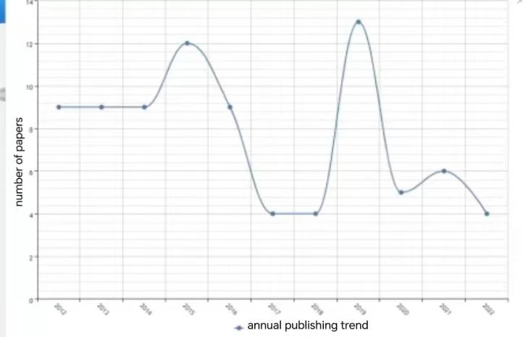

(Figure 1：numbers of annual publication)

Figure 2 shows that, in terms of the distribution among various disciplines, 30.77% of the papers about Barthes in China are related to comparative and world literature, 27.47% of them are relavant to literary theories, and about 10.99% are linked to Chinese language and literay writing. The above disciplines nearly account for two thirds of the papers, which reflects studies about Roland Barthes in China mostly focus on Barthes’ literary thoughts and the academic influence. For the research achievements in the fields of art, calligraphy, sculpture, photography, drama, film, and television, each of them accounts for 7%, which reflects Chinese scholars have been paying attention to the value of Barthes’ visual arts thoughts. In addition, some achievements scattere across different disciplines such as philosophy, culture, news media, education, ethics, aesthetics and Marxism.

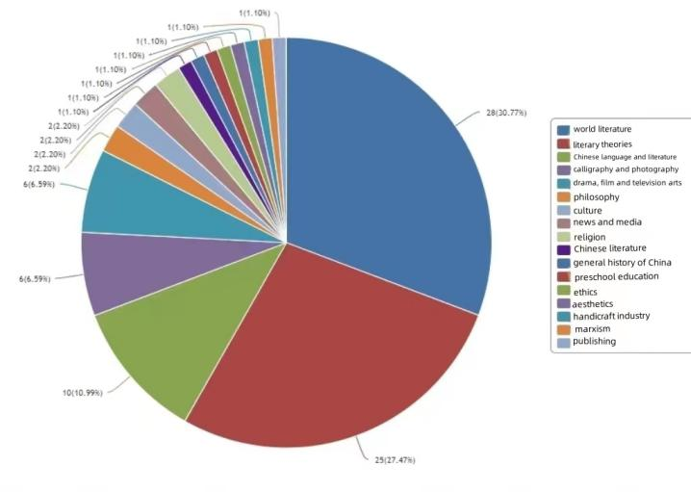

(Figure 2: discipline distribution map)

1. **Content analysis of data**

Based on the characteristics of purposive sampling, this article applys NVivo 14 software to conduct detailed research and analysis on the abstracts, titles and subtitles, keywords, and key sentences of 83 selected papers. Nodes, sub nodes, and reference points are selected, and qualitative analysis results are formed to model the themes and key points of studies about Roland Barthes in China in the past decade. The open encoding mainly involves organizing and analyzing raw materials, continuously reducing them by identifying phenomena, defining concepts and discovering categories. After the three-level encoding, 268 free nodes and 996 reference points were obtained.

Based on the conceptualization and categorization of the open encoding, the axial encoding performs a deep analysis of nodes, establishes logical relationships among categories, and categorizes 268 tertiary nodes into 32 secondary nodes.

|  |  |  |
| --- | --- | --- |
| No. | Secondary Nodes (32) | Nodes of concepts from the axial encoding |
| 1 | writing | zero writing, intransitive writing, white writing,;  neutral writing;  fragmented writing;  autobiographical writing; |
| 2 | author | the death of author |
| 3 | text | types of text; signs and symbols;  meaning of text;  literariness; aesthetic;  work and text; |
| 4 | narration | narrative structure |
| 5 | intertextuality | network hypertext |
| 6 | reading |  |
| 7 | reader |  |
| 8 | new criticism | avant garde |
| 9 | drama |  |
| 10 | poetry |  |
| 11 | pop culture |  |
| 12 | oriental culture |  |
| 13 | mythology |  |
| 14 | visual culture | film; advertisement; photography and photos;  image hierarchy theory; |
| 15 | consumer culture | fashion; |
| 16 | existentialism |  |
| 17 | structuralism and post structuralism | post structuralism and deconstructionism |
| 18 | psychoanalysis | love; body; desire; pornography;  death; mourning; Oedipus Complex; |
| 19 | marxism |  |
| 20 | ideology | the critique of ideology |
| 21 | confucianism; taoism；buddhism; |  |
| 22 | In China |  |
| 23 | skepticism |  |
| 24 | phenomenology |  |
| 25 | connotation |  |
| 26 | elements of signs | signifier; signified; sign |
| 27 | relation among signs | syntagmatic and paradigmatic relations |
| 28 | discourse analysis |  |
| 29 | rhetorics; style | style |
| 30 | metaphor |  |
| 31 | linguistic theories |  |
| 32 | meaning of language |  |

(Table 1：32 nodes by the axial encoding)

According to Grounded Theory, we move to the selective encoding on the basis of 32 secondary nodes which are obtained by the axial encoding and obtain 5 teritary nodes by analyzing and clarifying the intrinsic relationship and constructing the academic logic. And these five tertiary nodes can generally present the main topics of studies about Roland Barthes in China over the past decade, which namely are literature, culture, philosophy, semiology and linguistics (Table 2).

|  |  |  |
| --- | --- | --- |
| No. | Tertiary Nodes (9) | Nodes of concepts from the selective encoding |
| 1 | literature | writing; author; text; narration; intertextuality; reading; reader;  new criticism; drama; poetry; |
| 2 | culture | pop culture; oriental culture; mythology; visual culture;  consumer culture |
| 3 | philosophy | existentialism;  structuralism and post structuralism; psychoanalysis; marxism; ideology; confucianism; taoism; Buddhism; In China; skepticism; phenomenology; |
| 4 | semiology | connotation; signifer, signifed and sign;  syntagmatic and paradigmatic relations; |
| 5 | linguistics | discourse analysis; rhetorics; style; metaphor; linguistic theories;  Meaning of language |

(Table 2: 5 nodes by the selective encoding)

Based on Ground Theory, we applied the NVivo 14 software to conduct the three-layered encoding of collected data, and obtained the visualzied structural model of studies about Roland Barthes in China over the past ten years (Figure 3), then analyzed its features and trends of development in the future. As can be seen from Figure 3, the current research achievements of Barthes in China are mainly distributed in the fields of literature, culture, philosophy, semiotics and linguistics.

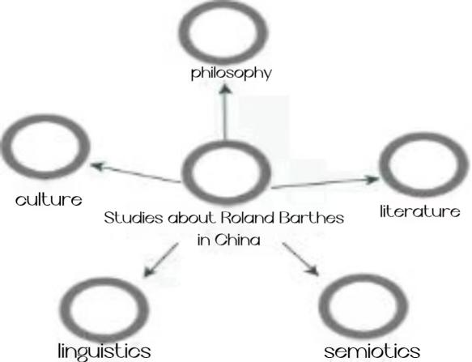

(Figure 3：the structural model of studies about Barthes in China over the past decade)

Then, we will illustrate the five branches shown by Figure 3 one by one. In the field of literary research, studies about Roland Barthes from the perspective of literary theory and literature accounts for the largest proportion, covering a large propotion of papers, which can be seen from the following Figure 4.

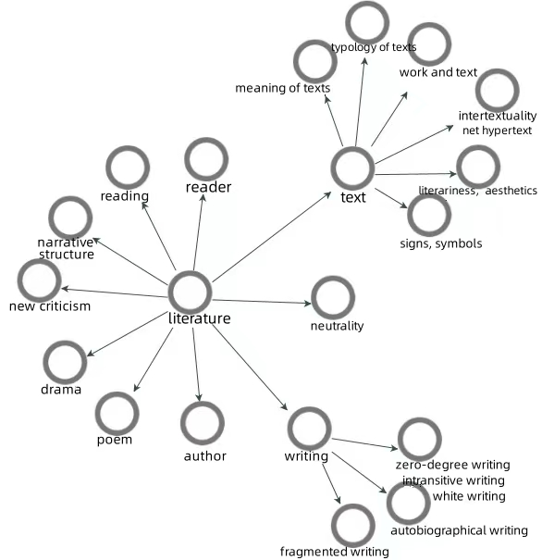

(Figure 4：the structural model of studies about Barthes related to literature)

It shows that a large group of Chinese scholars pay great attention to Barthes’ theories and thought on literary writing activities, which includes typology of writings and literature styles, zero-degree writing and so on. Among them, Barthes’ zero-degree writing, intransitive writing, or neutral writing, is most attractive and heatly discussed. Barthes laid so much emphasis on study of writing because of his study on literary styles and literariness. What’s more, his studies on writing ranging from zero-degree writing to neutral writing are also the reflection of his criticism of the ideological manipulation of literature. Gradually, Barthes developed the term of neutral writing, which became one of the most important key concepts in Barthes’ academic career, especially in his French College lectures. Therefore, neutral writing is an important clue to appreciate Barthes’ academic achievement.

In the mid-1950s, deeply influenced by structuralism searching for the deep structure and universal law in different fields, Barthes explored the deep structure of narrative works. His study about the deep narrative structure is considered as the beginning of modern narratology. Up to now, *Introduction to Structural Analysis of Narrative Works* by Barthes still stands in the classical bibliography for students who major in narratology and literary theories.

In his researches on the types of works, Barthes found that the meanings of some literary works are closed, while those of others are fluid and open. He proved the meanings of literary works shoud be diverse and plural by means of the fuzziness and ambiguity of language and carried out a form study on *Sarrasine* by Balzac. Once the meaning of the text is opened, Barthes found that the author who is traditionally considered as the origin of the meaning of text, should die metaphorically. And the death of the author intrigues the rebirth of readers with their own interpretations. Different interprations and meanings of texts are interwoven, which are just like onion and braided fabric wihout any center. Later, Barthes was deeply influenced by and strongly agreed on intertextuality by Kristeva.

1. As a social researcher, Barthes studied various mass cultural phenomena in France in the 1950s. He has made fruitful academic achievements in the field of cultural studies, which includes mass culure, mythologies, consumer culture and fashion, oriental culture, visual culture and so on (Figure 5). At the early stage, he analyzed the mass culture from the aesthetic perspective. Later, studying about the modern linguistics, he applied Saussure’s theory about signs to the study of mass culture and discovered the ubiquitous manipulation of ideology. Barthes explored the process of “naturalization” of bourgeoisie ideology by the means of signification of a signifier and its signified. With his studies about more linguists and their theories, Barthes absorbed linguistic ideas of Louis Hjelmslev’s glossematics, developed the one-to-one correspondence relation between a signifier and its signified into the multi-layered semiotics, which is proved to be a powerful tool for debunking the ideological mythology , which is named connotation semiotics.

In the 1960s, Barthes turned to study the social phenomenon of clothing fashion. He was very interested in the relationship among consumptionism, fashion and popularity and published his study findings in *The Fashion System*. The publication of this book marks the turning point of Barthes’ academic career. Its structure and research method acquire a strong sense of structuralism which aims to find the deep structure of phenomena, but it also foreshadows the later post-structuralist turn.

In the 1970s, Barthes visited Japan and developed a keen interest in Japanese culture. He studies various cultural phenomena and worked on the emptiness, fluidity and decentralization of meaning expressed in Japanese culture. What Barthes has found about meaning is highly identical to the concept of meaning developed by his post-structural studies. Barthes was deeply attracted by Chinese Confusionism, Buddhism and Taoism, and he quoted from ancient Chinese philosophy to illustrate his “neutral” thought. All these shows that there is an obvious internationalized trend in his research and he benefited a lot from the oriental cultures.

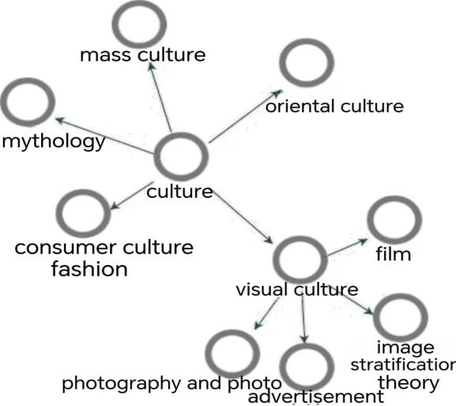

(Figure 5：the structural model of studies about Barthes related to culture)

1. The third theme of studies about Roland Barthes in China lies in the field pholosophy (Figure 6). Without exception, Barthes is deeply influenced by the the mainstream philosophical trends and popular theories at that time. At the early stage of his academic study, existentialism, phenomenology and skepticism of France exert wide influence on academic groups and their studies, which can be found in Barthes’ writing and thinking. Marxist philosophy, especially the view of history, materialism and ideological criticism, had a profound influence on Barthes’ literature and cultural research. Later, eches of two major academic trends of structuralism and post-structuralism can be heared in essays and books written by Barthes at that time.

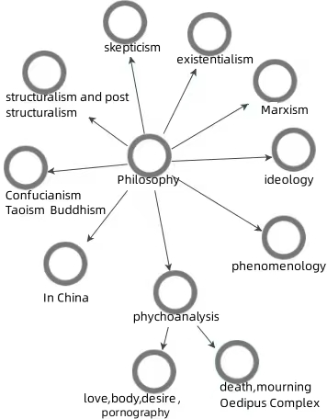

(Figure 6: the structural model of studies about Barthes related to philosophy)

In addition, Barthes melancholic temperament like that of a poet is reflected in his concern for love, desire, pornography and body. The death of his mother who accompanied him all his life made him deeply immersed in thinking about death and mourning. And his life-long dependence on his mother is easily reminiscent of the Oedipus Complex. Barthes not only has a deep and unique understanding of Western culture, but also has a unique insight into the heterogeneous Eastern culture. He has enriched his “neutral” thought from Confucianism, Buddhism and Taoism of Chinese culture, and was fascinated by the emptiness and decentralization of meaning from Japanese culture.

1. Semiotics is the fourth key word of studeis about Roland Barthes in China, and semiotic studies ranks as the most origional and creative part of Barthes’ academic life. His major contribution to semiotics lies in elements of a sign, signification of signs, denotation and connotation, and the syntagmatic and paradigmatic relations among signs, which are shown in Figure 7.

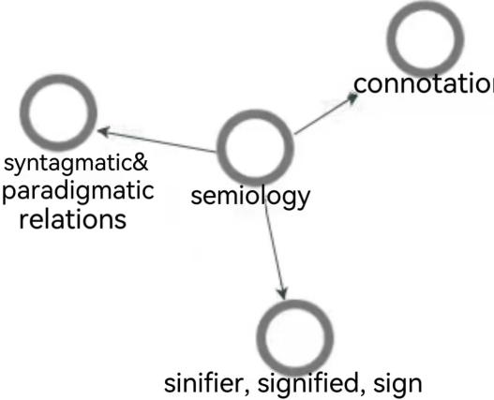

(Figure 7: the structural model of studies about Barthes related to semiotics)

Saussure’s linguistic semiotics is an important theoretical source of Barthes’ semiotic studies. Based on Saussure’s conception of signifier, signified and the signification between them to form a sign, Barthes also benefited from Hjelmslev’s glossematics and formed his multi-layered signification model. What’s more, Barthes applied this signifcation model study mass culture as a pioneer. His greatest academic contribution is to study and criticise ideology from the semiotic perspective.

Barthes believes that a signifier is not one-to-one correspndent to its signified and the signification between them might be multi-layered, which is more powerful to explain the literay meaning is open and fluid, not closed or definite. Therefore, the author who is traditionally considered as the origin of the sole meaning of literay work should die metaphorically. And it is unavoidable that various interpretaions from readers and critics will interweave and interact with each other, which makes intertextuality a must. In cultural studies, Barthes found that bourgeois ideology gained a seemingly natural legitimacy through connotation and the decentralization of oriental culture. In addition, Barthes applied the syntagmatic and paradigmatic relations of signs to the studies about the structural analysis of narrative works, popular culture and the fashion system.

1. As the powerful theoretical source of his study, Barthes benefited a lot from modern linguistics and also made his contribution to the study of linguistics, like the meaning of langague, styles, critical discouse analysis, metaphor and linguistic theories (Figure 8).

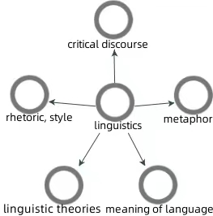

(Figure 8: the structural model of studies about Barthes related to linguistics)

From studies about lexical ambiguity, Barthes carried out his study about the meaning of a text and proved a literary work has no authorative and definite meaning at all because the meaning of language, which is used to write the liteary work, is not definite and sole. When he studied the form of literature, Barthes conducted systematic and profound studies on the development and change of style in the history of French literature which is regarded as the most typical typology of texts.

Metaphorical thinking is a distinctive feature of Barthes’ writing. Many a key concepts and theoretical ideas are metaphorically used by Barthes. He used “zero” writing, “intransitive” writing and also “neutural ” writing refer to the literariness of literary writing and the pursuit of pure beauty of form. By emphasizing the self-reflective writing, Barthes aims to aviod the manipulation and corruption of literature by ideology and to achieve the literariness. In addition, such concepts as “the death of author” and “text as an onion” proposed by Barthes also reflect his metaphorical writing style. Barthes has made efforts to unveil the ideological manipulation in his literay criticism and cultrual studies, and these studies profoundly explore the motivation, media and effects of all kinds of discouses, which is very similart to what critical discourse analysis has been doing.

1. **Conclusion and discussion**

Three following conclusions have been drawn from this study. Firstly, on the basis of Grounded Theory, the software NVivo 14 can efficiently abstract the features of the present studies about Roland Barthes in China over the past decade by the open encoding, the axial encoding and the selective encoding and also can reflect the developmet trend of studies about Roland Barthes in the future. Secondly, in the era of big data, the well developed AI technology and newly-updated softwares are proved to effectively process a large amount of literature data and has a powerful text mining function. Applied in the social science research, the NVivo 14 NVivo is powerful to do the visualized qualitative analysis of the current studies and can effectively improve the speed and accuracy of literature processing. Finally, it is found that studies about Roland Barthes in China mainly distributed among the following five fields, namely, literature, culture, philosophy, semiotics and linguistics. Such problems as repetition, lack of origionality, and highly sepearated by disciplines urgently need to be addressed. In the future, greater efforts should be made to achieve the higher quality studies about Roland Barthes in China, to more actively engage in the international academic dialogue and communication。

**Statements and Declarations**

**Funding**

The author(s) disclosed receipt of the following financial support for the research, authorship, and/or publication of this article: This work was supported by a project grant from Hangzhou Planning Program of Philosophy and Social Science [2021, No. Z21JC082] and one by 2023 Zhejiang Province Philosophy and Social Science Planning Project of Xi Jinping’s Thought Research Center [2023, No.23CCG47].

**Declaration of conflicting interests**

The author(s) declared no potential conflicts of interest with respect to the research, authorship, and/or publication of this article.

**References**

Bazeley, P., & Jackson, K. (2013) Qualitative Data Analysis with NVivo. *Sage Publication.*https://us.sagepub.com/sites/default/files/upm-assets/114916_book_item_114916.pdf

Chen, X. M., (2008) The New Development of Qualitative Research and its Ssignificance to Social ScienceResearch. *Educational Research and Experiment*, (2), 14-18. https://www.scirp.org/reference/referencespapers?referenceid=3100456

Evers, J. C., (2011) From the Past into the Future. How Technological Developments Change Our Ways of Data Collection, Transcription and Analysis. *Forum: Qualitative Social Research*, 12 (1), Article No.8. https://www.researchgate.net/publication/48666998_From_the_Past_into_the_Future_How_Technological_Developments_Change_Our_Ways_of_Data_Collection_Transcription_and_Analysis

Gao, R. J., Ao, Y. L., Liu, Y. Q., & Zhang, L., (2021) A Study on Ideological and Political Teaching of Current Foreign Language Courses in Colleges and Universities —— From a Qualitative Research Perspective Based on NVAivo. *Journal of Chengdu Aeronautic Polytechnic*, (4), 13-15-61.

Glaser, B. G., Strauss, A. L., & Strutzel, E., (1968) The Discovery of Grounded Theory; Strategies for Qualitative Research. *Nursing Research*, 17(4), 364. DOI: 10.1097/00006199-196807000-00014

Hutchison, A. J., Johnson, L. H., & Brekon, J. D., (2010) Using QSR-NVivo to Facilitate the Development of a Grounded Theory Project: An Account of a Worked Example. *International Journal of Social Research Methodology*, 13(4), 283-302. http://dx.doi.org/10.1080/13645570902996301

Liu, S. M., & Li, Z. W., (2017) The Essential Software of Qualitative Research: Nvivo 10 Iconography and Application, The Economic Daily Press.

Luo, H.W., Ding, W., Wang, Q. K., Niu, J. & Li, Y., (2011) A NVivo-based Qualitative Study on the Emotive Factors Associated with Nil Dropout in Open English Education. *Open Education Research*, (6): 98-103. http://www.irtree.cn/3233/articles/40230336/article_detail.aspx

Ma, X., (2022) Research on the Mechanism of Traditional Culture Blending into Ideological and Political Education in Colleges and Universities——Qualitative Analysis Based on Grounded Theory. *Journal of Liaoning Provincial College of Communications*, (6), 65-69.

Pan, H., & Tang, L., (2020) Qualitative Data Analysis in Chinese Social Science Studies ——The Case of NVivo. *Data Analysis and Knowledge Discovery*, (1), 51-62. https://doi.org/10.11925/INFOTECH.2096-3467.2019.1227

Sun, J. W., & Wang, L. F., (2021) Application of NVivo modeling method in translation studies. *East Journal of Translation*, (1), 35-44.

Zhang, J. J., (2018) The Current Representation and Discursive Construction of Filial Piety in the Context of New Media ——An NVivo Analysis of Data Collected from Sina Weibo. *Journal of Nanjing Normal University* (Social Science Edition), (2), 15-23.

1. This paper was supported by a project grant from Hangzhou Planning Program of Philosophy and Social Science (2021, No. Z21JC082) and one by 2023 Zhejiang Province Philosophy and Social Science Planning Project of Xi Jinping’s Thought Research Center (2023, No.23CCG47).
2. SI Wenhui (1980-) received B.A. degree in English education from Qufu Normal University in 2002, M. A. degree in English Language and Literature from Hunan Normal University in 2005, and Ph. D. degree in English Language and Literature from Sichuan University in 2012. She is currently an associate professor and a master supervisor in School of Foreign Languages, Zhejiang Gongshang University, Hangzhou, China. Her research interests include Western Literary Theory, Social Semiotics and Foreign Language Teaching Research.