SPARSE STATISTICAL MODELING FOR QUALITY CONTROL IN HIGH-DIMENSIONAL INDUSTRIAL PROCESSES USING LASSO LOGISTIC REGRESSION
Maricela Ormaza¹ and Ismael Yépez²
¹ Department of School of Business and International Trade, Pontifical Catholic University of Ecuador Ibarra, Ibarra, 100150 Ecuador
² Higher University Institute Cotacachi, Cotacachi, 100301 Ecuador
Corresponding author: First A. Author (mformaza@pucesi.edu.ec).

Abstract
Purpose: Develop a model for identifying the most relevant quality dimensions for predicting defective products in an industrial setting, using high-dimensional variables and applying Lasso logistic regression from the binomial family. This involves decomposing an input vector , into a linear combination of a reduced number of basic elements from a matrix , where In this context, represents the number of manufactured products and p represents the quality dimensions of each product. The aim is to approximate, where is a sparse vector containing k non-zero coefficients, with . Design/methodology/approach: Lasso logistic regression from the binomial family was used, complemented with other tools to validate the model. Findings: The model present 408 significant variables out of a total of 1,555 features. These were categorized into five zones according to their impact: critical (4.17%), important (8.09%), moderate (41.42%), minimal (46.08%), and irrelevant (0.25%). The model achieved a binomial deviance of 0.61, demonstrating its effectiveness in identifying and prioritizing critical quality characteristics in complex industrial processes. Originality/value: This methodology provides a practical tool for monitoring and quality control in industrial environments where high-dimensional binary data is generated.
Keywords: quality control; high-dimensional variables; complex industrial processes; model Lasso; defective products; logistic regression, sparse vector.
1. Introduction
In an industrial manufacturing environment, production processes are defined to manufacture a set of N products that satisfy p quality characteristics (Stanković et al., 2024; Jalilibal et al., 2024).These characteristics, ranging from physical properties to aesthetic and functional aspects, are determinants of customer satisfaction (Heydari, Alinezhad and Vahdani, 2024). Consequently, they influence the product’s success in the market (Shi, Liedl, and Bauernhan, 2024).The quality of a product can be formally defined as a multidimensional function where represents the overall quality of the product, and are the individual quality characteristics. Each defined during the product design phase, considering customer expectations (Ait et al., 2024). Quality control in these processes involves detecting defects, which can be mathematically expressed as identifying significant deviations where is a predefined tolerance threshold for each characteristic.
Quality control in these processes involves detecting defects, which can be mathematically expressed as identifying significant deviations where is a predefined tolerance threshold for each characteristic. Mathematically, the p characteristics of a batch of N manufactured products can be represented in a matrix . Traditionally, the total number of manufactured products (N) is much greater than the quality characteristics (p); that is, N>>p. Therefore, a compendium of applicable statistical tools for defect detection has been developed (Siegel, 2012). Some of these tools are detailed in the studies by Kiran (2017) and Ross (2017). The main tools include quality control charts for variables and attributes (Kumar and Singh, 2023), histograms (Yalman, 2014), Pareto charts, scatter diagrams, root cause analysis, process capability metrics (Kumar and Singh, 2023; Shen et al., 2024), regression analysis for low-dimensional data, hypothesis testing (Flott, 1996), analysis of variance (Ramsey, 1993), and multivariate control charts (Lörchner t al., 2022).
However, technological advancements have led to scenarios in which , meaning that the number of characteristics significantly exceeds the number of analyzed products. This phenomenon, known as high dimensionality, presents unique challenges for quality analysis and control (Jalilibal et al., 2024). Issues associated with high dimensionality include the "curse of dimensionality" (Bai, Cheng and Zhao, 2019), where the density of data decreases exponentially as dimensions increase; overfitting (Deprez and Robinson, 2024), which hampers the generalization of models; multicollinearity, which complicates both the interpretation and stability of estimates; limitations in the effective visualization of data (Han et al., 2012); and the high computational cost in processing large volumes of data (Theodoridis, 2015).
Sparse statistical modeling has emerged as a promising approach to address these challenges. This method seeks to select a small but significant subset of variables from an extensive set (Omara and Alotaibi, 2023). Among the sparse modeling techniques, notable methods include the Least Absolute Shrinkage and Selection Operator (LASSO), ridge and elastic net regression families (Lamberti, 2023), tree-based methods (Lin, Wang and Sadek, 2015), sparse least squares (Zheng and Wang, 2024), sparse component analysis (Zhang, Xu and Zhang, 2019), and Bayesian methods (Zhang et al., 2024).
The objective of this study is to develop a model for the automatic identification of the most influential quality dimensions in predicting defective products in an industrial environment with high-dimensional variables through the application of LASSO logistic regression from the binomial family. The goal is to decompose an input vector into a linear combination of a few basis elements from matrix , where Here, N is the number of manufactured products and 𝑝 represents the quality dimensions for each of them. The aim is to approximate, where is a sparse vector of 𝑘 non-zero coefficients .
1. Materials and Methods
Two datasets are available. The first is a matrix and a vector Y; with n = 756 observations and p = 1555 features. The matrix is represented as follows:
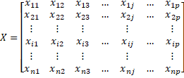 | (1)

Where .
Each row vector, represents the characteristics of the -th product. Each column vector represents the values of the -th characteristic for all products. Each component indicates the presence (1) or absence (0) of quality defects in the j-th characteristic for the 𝑖-th product. Each product is manufactured in the same system.
Approximately, in the matrix only 1% de las p of the 𝑝 characteristics are non-zero or defective for a given product, a figure determined from the expression:

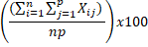 | (1)

The vector is also binary and is obtained from the matrix . Each element represents the quality classification assigned to each 𝑖-th product in the matrix , based on the total defects found in the 𝑗-th characteristics. The classification equation is expressed as follows:

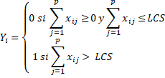 | (1)

Where is the sum of the elements in each -th row of the matrix representing the total defects per product, and LCS is the upper control limit defined by the analyst according to their needs, constrained by .
Essentially, if the sum of the elements from to is greater than or equal to 0 and less than or equal to LCS, then "acceptable quality product”. On the other hand, if the sum of elements in the same range exceeds LCS, then “defective product”. In summary, 0 is assigned when the total sum of defects for each product in matrix matrix falls within the range of , and 1 is assigned when the sum is out of range, specifically when it is greater than LCS.
With LCS = 17 defects, n = 756 products, and p = 1555, the percentage of units with acceptable quality was determined using the expression. Which can be interpreted as the elements in the vector that are equal to zero.
Both the datasets were stored in an *. xls spreadsheet named “Binarios”. To address the high-dimensionality problem and select the most relevant features, a logistic regression model with Lasso regularization was used. Logistic regression with L1 regularization takes the following form:

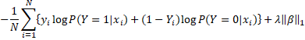  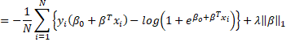 | (1)

Where is the total number of observations in the dataset, es la -th observation of the dependent binary variables, is the feature vector or independent variables for the -th observation, and is the model coefficient, and is the regularization parameter. The equation itself has two components: the first is the negative log-likelihood expression for binary logistic regression: , obtained after applying the negative natural logarithm to the original likelihood function (Eq. 6), while the second component, the L1 penalty, integrates two elements: representing the L1 regularization parameter and norma .
Regarding the expression , the L1 norm () of vector is defined as the sum of the absolute values of its components. In other words, for vector the norm is expressed as, which measures the total magnitude of the coefficients. λ is a regularization parameter that controls the strength of the penalty. The larger λ is, the greater the penalty, leading to smaller coefficients. This additional penalty has the effect of “shrinking” some coefficients towards zero, and in some cases, may cause certain coefficients to be exactly zero.
The incorporation of penalti into the objective function of the LASSO logistic regression enables automatic feature selection. By forcing some coefficients to zero, the lasso tends to select a more relevant subset of features, eliminating less important ones. This could result in simpler and more generalizable models.
For data analysis, the R programming language, originally created by Ihaka and Gentleman (1996), version 4.3.2, was used, the latest available at the time this work was carried out. For reading the data in R, the “readxl” library, created by Wickham and Bryan (2019), was used. To generate the model, the “glmnet” library was employed. This library, developed by Friedman, Hastie and Tibshirani
(2023), primarily packages regularization methods to fit generalized linear models with L1 (lasso) and L2 (ridge) regularization.
The “cv.glmnet” function from this library was used to generate the Lasso logistic regression for the binomial family, including cross-validation. This allowed for automatic selection of the best value for the regularization parameter λ.
A regularization path plot is used to visualize and select the optimal value of the regularization parameter λ as it changes. This tool places logarithmic values that λ can take on the x-axis. As λ increases, moving from left to right, the penalty on the coefficients increases. The y-axis displays the values of binomial deviance, also known as loss. Vertical lines and points are placed on the plot: the vertical lines represent different values of λ, whereas the points on the line indicate the average deviance on the validation set for a specific λ value. A lower score indicates better performance.
Binomial deviance is a metric used to evaluate how well the binomial logistic regression model fits the observed data, and is defined as . Where is the binomial deviance, is the log-likelihood of the fitted model, is the log-likelihood of a null model that predicts the most common probability. where represents the actual values, represents the model predictions, and represents the most common probability in the data.
The “coef” and “$lambda.min” functions from the same “glmnet” library were used to extract the model”s coefficients and the best value of lambda (λ*), respectively.
The coefficient path plot is a visual representation of how the model”s coefficients change as lasso regularization is applied. The values of λ that control the level of regularization applied to the model are shown on the horizontal x-axis. As λ increases, the penalty for the coefficients increases. The vertical y-axis represents the values of model coefficients. Each line in the plot represents the variation of a particular coefficient as λ increases. From left to right, as λ increased, some coefficients tended to decrease and eventually reached zero. The points where the lines touch the y-axis represent the coefficients for the different values of λ. Inflection points where the lines change direction indicate significant changes in the coefficients. The vertical line marks the value of λ∗ selected through cross validation. This point represents the optimal balance between the fit and regularization.

3. Results
The LASSO logistic regression model for the binomial family was generated using the following code.
datos <- read_excel("Binarios.xlsx", sheet = "Hoja1", n_max = 756)
y <- datos$Calidad
filas_seleccionadas <- 1:756
columnas_seleccionadas <- 5:1559
x <- datos[filas_seleccionadas, columnas_seleccionadas]
lasso_model <- cv.glmnet(as.matrix(x), as.factor(y), family = "binomial")
plot(lasso_model)

The function of the first line of code is to store all the input data for the model in a single variable named “datos”, using the “read_xlsx” function from the “readxl” library. From this dataset, two variables were extracted: the variable “y,” which stores the data vector Y (line 2), and the variable “X,” which stores the data for the matrix (from lines 3 to 5).
The logistic regression model with regularization for the binomial family was generated after running line 6, using the cv.glmnet function from the “glmnet” library. This function fits the desired model by applying Eq. 4, but cross-validation was also performed to automatically select the best value of λ. Line 7 generates Graph 1, which represents the regularization path of the generated model. The plot provides information on how the performance of the model changes with different values of the regularization parameter λ.

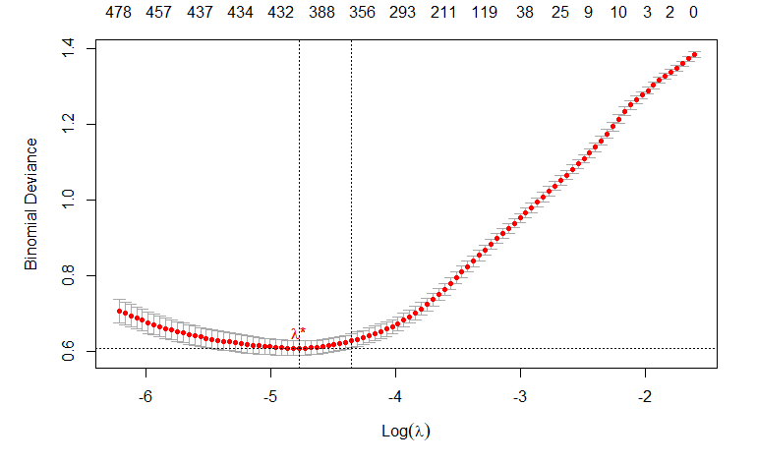
Graph 1. Regularization path of the generated model. Cross-validation for the data in matrix representing the quality defects of the N manufactured products. Two dotted vertical lines can be observed. Both represent the value of λ that minimizes the binomial deviance. From left to right, the first profiles a model with the largest number of variables, while the second with the fewest. The number of non-zero coefficients is displayed at the top of the graph.
The best value of lambda corresponds to -4.87, with a total of 408 variables and a binomial deviance of 0.61. This was obtained by executing the following lines of code:
best_lambda <- lasso_model$lambda.min
coefficients_best_lambda <- coef(lasso_model, s = best_lambda)
num_variables_seleccionadas <- sum(coefficients_best_lambda != 0)
min_deviance <- min(lasso_model$cvm)
lasso_path_model <- glmnet(as matrix (x), as factor (y), family = "binomial,” alpha = 1)
plot(lasso_path_model, xvar = "lambda", label = TRUE)
abline(v = log(best_lambda), col = "red", lty = 2)

After executing lines 5, 6, and 7, a coefficient variation plot was obtained, as presented in Graph 2.
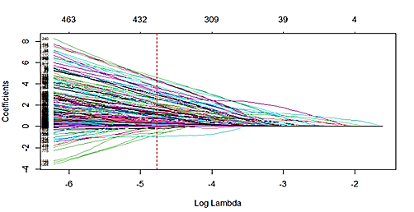
Graph 2. Coefficient Variation Plot. The coefficient variation plot of the 𝑝 defective features of the manufactured products for the logarithmic values of 𝜆. The number above indicates the number of filtered coefficients.
The set of features selected in the LASSO logistic regression model was designated as the essential sparse features. This term is situated within the context of sparse statistics, referring to the variables or features identified as the most important and relevant after applying feature selection techniques to a high-dimensional dataset. In high-dimensional datasets, where the number of features significantly exceeds the number of observations, it is assumed that most of these variables are irrelevant or of little importance in explaining the phenomenon of interest. This underlying structure is known as “sparse”.
Essential sparse features are relevant for predicting the response variable when it is one; in this case, the probability of producing defective products. These variables have nonzero coefficients in the model, indicating that they contribute to the prediction that the response variable is equal to 1. On the other hand, the non-selected features have coefficients equal to zero in the Lasso model. This indicates that, according to the lasso regularization process, these variables do not significantly contribute to the prediction and have been “filtered” or excluded from the final model. In other words, the model automatically selects features, retaining only those features that have a substantial impact on the prediction, and discarding those that do not contribute significantly. Therefore, the selected features (essential sparse features) in the model substantially contribute to the prediction of defective products.
In Graph 3, two scatter plots can be seen. From left to right, the first represents the quality defects (black points) for the 1555 quality features (y-axis) and 756 manufactured products (x-axis). In the second scatter plot, the black points are converted to red, indicating essential sparse features. Scatter plot 1 was generated by executing code lines 1-22 in Appendix A, whereas scatter plot 2 was generated by executing code line 23 from the same appendix.

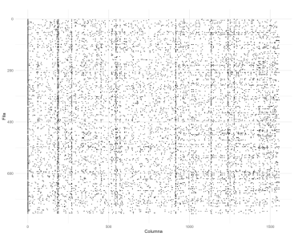 | 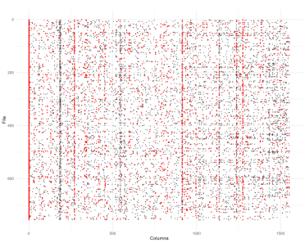
(a) | (b)

Graph 3. Two (2) scatter plots: (a) Shows quality defects (black points) for each 𝑝 dimensions and 𝑁 manufactured products; (b) Identifies the essential sparse features (red points) defined in the generated model.
Each scatter plot was obtained by plotting a point at the coordinates where each element xi belonging to matrix is equal to 1. For , which represents the element in row 𝑖 and column 𝑗 of the matrix ; the set of positions of elements equal to 1 is defined as: .
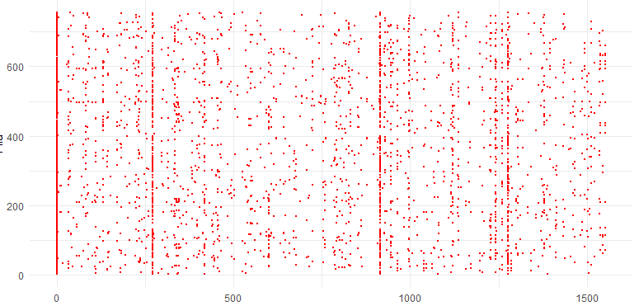
Graph 4. Scatter plot representing only the essential sparse features (red points) defined in the generated model.
Graph 4 is generated after executing the programming code, as shown in Appendix B. In this instance, the analysis focused on the essential sparse features identified in the model. Graph 5 graphically represents the coefficients for each of the essential sparse features selected by the logistic regression model with binomial family regularization. This is useful for visualizing the direction and magnitude of coefficients.
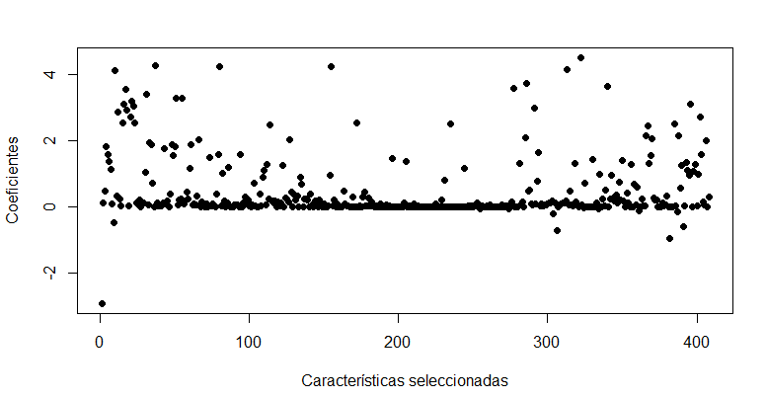
Graph 5. Graphical representation of the coefficients for each of the variables selected by the logistic regression model with binomial family regularization. The x-axis corresponds to the variables selected by the logistic regression model with binomial family regularization, and the y-axis represents the value of the coefficients. Each point represents a specific coefficient for each of the selected features.
In Graph 6, a bar chart for each coefficient is presented. Graphs 5 and 6 were generated after executing the programming code shown in Appendix C.
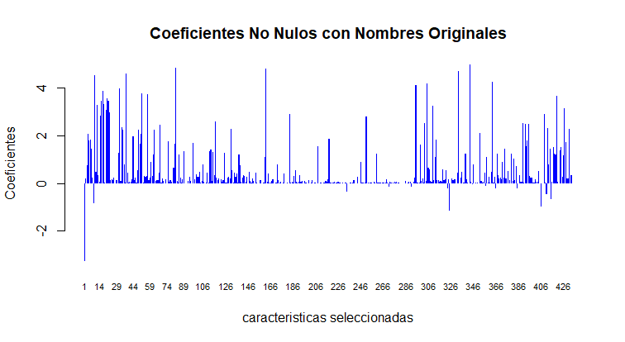
Graph 6. Bar chart representing the coefficient values for each of the variables selected by the logistic regression model with binomial family regularization.
It can be observed that the majority of the coefficients have a positive sign, while a minority have a negative sign. The features selected in the model with a positive coefficient indicate a positive association between that feature and the probability of the event occurring, in this case, the presence of a defective product. Simply put, the probability of a defective product tends to increase as the value of the selected positive variable increases. A higher positive coefficient indicates that an increase in the value of the variable is more strongly associated with an increase in the probability of obtaining defective products. The greater the absolute value of the positive coefficient, the greater is the impact of that variable on predicting the probability of the event. A higher coefficient implies a stronger influence of the variable on the outcome of the model.
Meanwhile, negative coefficients indicate a negative association between the corresponding feature and probability of an event of interest. In the context of quality control, features with negative coefficients may suggest characteristics or conditions associated with a reduction in the probability of defects in manufactured products. A lower negative coefficient indicates that the corresponding variable has less influence on increasing the probability of obtaining defective products compared to the other variables. The magnitude of the negative coefficient was inversely related to the impact of the variable on the probability of an event. A lower negative coefficient indicates a smaller impact on reducing the probability of an event, in this case, the occurrence of defective products.
In Graph 3, a segmentation layer is added that divides the points into five categories, providing a more structured representation of the contribution of each essential sparse feature to the generated lasso-regularized logistic regression model. This visually highlights the segmentation of each point based on its influence on the probability of producing defective units (Fig. 5).
Each zone represents different levels of impact of the essential sparse features on the manufacturing of defective units. Specifically, Zone 1 contains critical features with higher coefficients that exert a significant influence. Zone 2 presents important features with less impact. Zone 3 included moderate attributes that contributed in a balanced manner. Meanwhile, Zone 4 encompasses features with minimal impact, but with limited contribution. Zone 5 consisted of features that were practically irrelevant. Graph 7 is generated from the execution of the programming code presented in Appendix D.
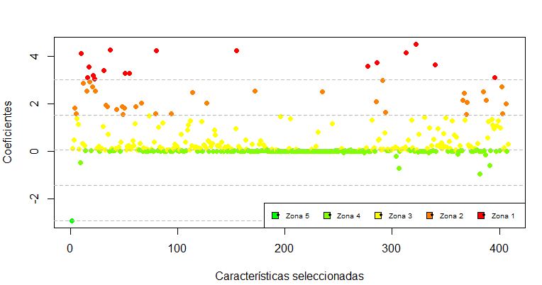
Graph 7. of essential sparse features according to their influence on the probability of manufacturing defective units. Each point represents one of the features selected by the model. The distance between the y-axis and zero for each point determines the value of each coefficient for each feature. The graph is segmented into three critical horizontal regions, both positive and negative, based on a duplicated coefficient.
The segmentation ranges of β, counts, percentages, and variables for each zone are presented in Table 1.

Zone | β Zoning Range | Count | Percentage | Essential Features
Zone 1: Critical Essential Features | 3.02 ≤ β ≤ 4.5 | 17 | 4.17% | D32, D40, D43, D47, D56, D89, D111, D151, D171, D241, D495, D973, D1010, D1116, D1158, D1243, D1486
Zone 2: Important Essential Features | 1.54 ≤ β ≤ 3.02 | 33 | 8.09% | D6, D9, D34, D39, D44, D46, D63, D100, D107, D131, D145, D146, D147,…, D1539
Zone 3: Moderate Essential Features | 0.06 ≤ β ≤ 1.54 | 169 | 41.42% | D2, D3, D12, D15, D17, D33, D36, D71, D76, D77, D83, D86, D88, D91,…, D1552
Zone 4: Minimal Impact Essential Features | -1.42 ≤ β ≤ 0.06 | 188 | 46.08% | D29, D37, D45, D81, D110, D113, D114, D121, D142, D199, D208, D221, D224, D228, D233, D237, D248,…,D1545
Zone 5: Irrelevant Essential Features |  | 1 | 0.25% | D1
Total | -2.49 ≤ β ≤ -1.42 | 408 | 100.00%
Table 1. Segmentation of points based on their influence on the probability of producing defective units
The zoning range according to β was obtained using the expression, with n = 5. This equation divides the entire range of coefficients into in equal segments, and assigns the lower limit of the range ( to each zone i.
3. Discussion
The segmentation performed in this study provided a structured interpretation of the influence of each characteristic on the probability of producing defective units. In zone 1 (critical characteristics), 17 characteristics (4.17% of the total) were identified, with the highest coefficients (3.02 ≤ β ≤ 4.5), indicating a significant impact on defect prediction. The presence of these characteristics notably increases the probability of the product being defective. In zone 2 (important characteristics), 33 characteristics (8.09%) were grouped, showing a considerable impact on product quality, with coefficients ranging from 1.54 to 3.02, although their influence was lower than that of zone 1. Zone 3 (moderate characteristics) includes the majority of the selected characteristics (169, 41.42%), with coefficients between 0.06 and 1.54, suggesting a moderate but consistent impact on product quality. zone 4 (minimal impact characteristics) encompasses 188 characteristics (46.08%) with coefficients close to zero (-1.42 ≤ β ≤ 0.06), indicating an almost negligible effect on defect prediction. Finally, in zone 5 (irrelevant characteristics), only one characteristic (0.25%) falls into this category, with a highly negative coefficient (-2.49 ≤ β ≤ -1.42), suggesting that its presence is associated with a reduction in the probability of defects, although its impact is limited.
These results demonstrate the existence of an underlying structure that can be categorized, as established by the principles of sparse modeling mentioned in Jalilibal et al. (2024), now validated in the context of quality control in industrial processes.
These results have significant implications for quality control in high-dimensional industrial environments. First, prioritizing efforts on the characteristics of Zones 1 and 2 should be the focus of quality control, given their high impact on defect generation. Furthermore, process optimization can be more effective when concentrating on critical characteristics, thereby improving the quality of the final product. This aligns with the observations of Siegel (2012), who asserts that quality control should focus primarily on the most influential factors in the generation of defective products.
Additionally, these findings can guide the design of more efficient monitoring systems by concentrating resources on the most influential characteristics, which also contributes to cost reduction in monitoring less relevant features. Finally, this approach facilitates continuous improvement, providing a framework for the periodic re-evaluation of critical characteristics as production processes evolve.
While the existing literature demonstrates instances of studies that have employed LASSO regression to select variables in industrial processes strongly correlated with quality, such as the study presented in Song et al. (2022), the present work stands out by specifically addressing high-dimensional binary variables, an additional challenge in terms of complexity and the selection of relevant features in industrial contexts.
Sparse modeling, specifically lasso regression, has emerged as an effective solution to address the challenges related to quality control in high-dimensional industrial environments. By applying L1 regularization, Lasso allows for the automatic selection of a subset of relevant features, reducing noise and eliminating less influential characteristics. This is particularly valuable in scenarios where large quantities of variables are managed, such as product quality within manufacturing processes. By accurately identifying critical characteristics that influence defect production, Lasso not only optimizes the monitoring and control process, but also enhances efficiency and reduces costs by focusing on areas that truly impact quality. Thus, LASSO regression provides a robust and scalable methodology for decision making in the realm of industrial quality control, contributing to continuous improvement and process optimization.

Declaration of Conflicting Interests
The author(s) declared no potential conflicts of interest with respect to the research, authorship, and/or publication of this article.
Funding
The author(s) received no financial support for the research, authorship, and/or publication of this article.
References
Ait El Cadi, A., Gharbi, A., Dhouib, K., & Artiba, A. (2024). Joint production, maintenance, and quality control in manufacturing systems with imperfect inspection. Journal of Manufacturing Systems, 77, 848–858. https://doi.org/10.1016/j.jmsy.2024.10.020
Bai, E., Cheng, C., & Zhao, W. (2019). Variable selection of high-dimensional non-parametric nonlinear systems by derivative averaging to avoid the curse of dimensionality. Automatica, 101, 138–149. https://doi.org/10.1016/j.automatica.2018.11.019
Deprez, M., & Robinson, E. C. (2024). Dimensionality reduction. In Elsevier eBooks (pp. 105–137). https://doi.org/10.1016/b978-0-12-822904-0.00010-8
Flott, L. W. (1996). Quality control. Metal Finishing, 94(9), 76–122. https://doi.org/10.1016/0026-0576(96)82108-8
Friedman, J., Hastie, T., & Tibshirani, R. (2023). Package 'glmnet': Lasso and Elastic-Net Regularized Generalized Linear Models (Version 4.1-8). Retrieved from https://cran.r-project.org/web/packages/glmnet/glmnet.pdf
Han, J., Kamber, M., & Pei, J. (2012). Getting to know your data. In Elsevier eBooks (pp. 39–82). https://doi.org/10.1016/b978-0-12-381479-1.00002-2
Heydari, M., Alinezhad, A., & Vahdani, B. (2024). A deep learning framework for quality control process in motor oil industry. Engineering Applications of Artificial Intelligence, 133, 108554. https://doi.org/10.1016/j.engappai.2024.108554
Ihaka, R., & Gentleman, R. (1996). R: A language for data analysis and graphics. Journal of Computational and Graphical Statistics, 5, 299–314.
Jalilibal, Z., Ahmadi Karavigha, M. H., Maleki, M. R., & Amiri, A. (2024). Control chart methods for tracking high-dimensional data flows: A conceptual classification scheme. Computers & Industrial Engineering, 191, 110141. https://doi.org/10.1016/j.cie.2024.110141
Kiran. (2017). Quality gurus. In Elsevier eBooks (pp. 21–37). https://doi.org/10.1016/b978-0-12-811035-5.00003-9
Kumar, A., & Singh, R. (2023). On direct metal laser sintering of functional prototype: X and R-chart and analysis of process capability. Materials Today: Proceedings. https://doi.org/10.1016/j.matpr.2023.10.052
Lamberti, W. F. (2023). An overview of explainable and interpretable AI. In Elsevier eBooks (pp. 55–123). https://doi.org/10.1016/b978-0-32-391919-7.00015-9
Lin, L., Wang, Q., & Sadek, A. W. (2015). A novel variable selection method based on frequent pattern tree for real-time traffic accident risk prediction. Transportation Research Part C: Emerging Technologies, 55, 444–459. https://doi.org/10.1016/j.trc.2015.03.017
Lörchner, C., Horn, M., Berger, F., Fauhl-Hassek, C., Glomb, M. A., & Esslinger, S. (2022). Quality control of spectroscopic data in non-targeted analysis: Development of a multivariate control chart. Food Control, 133, 108601. https://doi.org/10.1016/j.foodcont.2021.108601
Omara, A., & Alotaibi, A. S. (2023). GLOBE: A novel pruning-based sparse modeling with application to time series data representation. Journal of King Saud University: Computer and Information Sciences, 35, 101800. https://doi.org/10.1016/j.jksuci.2023.101800
Ramsey, M. H. (1993). Sampling and analytical quality control (SAX) for improved error estimation in the measurement of Pb in the environment using robust analysis of variance. Applied Geochemistry, 8, 149–153. https://doi.org/10.1016/s0883-2927(09)80027-9
Ross, S. M. (2017). Analysis of variance. In Elsevier eBooks (pp. 489–518). https://doi.org/10.1016/b978-0-12-804317-2.00011-4
Shen, Z., Chen, D., Zhao, L., & Wei, Y. (2024). Towards the balance between computational cost and model performance for the void detection of concrete-filled steel tubular structure using one-dimensional Mel-frequency cepstral coefficients and ensemble machine learning. Construction and Building Materials, 411, 134366. https://doi.org/10.1016/j.conbuildmat.2023.134366
Shi, A. de Dachuan, Liedl, P., & Bauernhansl, T. (2024). Interoperable information modeling leveraging asset administration shell and large language model for quality control towards defect-free manufacturing. Journal of Manufacturing Systems, 77, 678–696. https://doi.org/10.1016/j.jmsy.2024.10.011
Siegel, A. F. (2012). Quality control. In Elsevier eBooks (pp. 523–543). https://doi.org/10.1016/b978-0-12-385208-3.00018-3
Song, B., Jin, Y., Guo, T., Shi, H., Tao, Y., & Tan, S. (2022). Quality-related fault detection method based on LASSO-orthogonal canonical correlation analysis. In Proceedings of the 2022 41st Chinese Control Conference (CCC) (pp. 2591–2595). Hefei, China. https://doi.org/10.23919/CCC55666.2022.9901946
Stanković, K., Jelić, D., Tomašević, N., & Krstić, A. (2024). Optimization of manufacturing process for real-time quality control under multi-regime conditions: Use case in tire tread band production. Journal of Manufacturing Systems, 76, 293–313. https://doi.org/10.1016/j.jmsy.2024.07.015
Theodoridis, S. (2015). Sparsity-aware learning. In Elsevier eBooks (pp. 449–507). https://doi.org/10.1016/b978-0-12-801522-3.00010-0
Wickham, H., & Bryan, J. (2024). Readxl: Read Excel Files (R package version 1.3.1). Retrieved from https://CRAN.R-project.org/package=readxl
Yalman, Y. (2014). Histogram-based perceptual quality assessment method for color images. Computers & Standards Interfaces, 36(6), 899–908. https://doi.org/10.1016/j.csi.2014.04.002
Zhang, C., Xu, S., & Zhang, J. (2019). A novel variational Bayesian method for variable selection in logistic regression models. Computational Statistics & Data Analysis, 133, 1–19.
Zhang, Q., Xu, W., Xie, L., & Su, H. (2024). Dynamic fault detection and diagnosis for alkaline water electrolyzer with variational Bayesian sparse principal component analysis. Journal of Process Control, 135, 103173. https://doi.org/10.1016/j.jprocont.2024.103173
Zheng, W., Wang, C., & Li, D. (2024). Combustion process modeling based on deep sparse least squares support vector regression. Engineering Applications of Artificial Intelligence, 132, 107869. https://doi.org/10.1016/j.engappai.2024.107869

