RFID monitoring system using Machine Learning: A Design Thinking approach for smarter attendance solutions

Dr. B. Sivasankari
Department of ECE
SNS College of Technology Coimbatore, India
sivasa.b.ece@snsct.org

K. Surya Kannan
Department of ECE
SNS College of Technology
Coimbatore, India
suryakan.k.ece.2020@snsct.org

R. Vishwamoorthy
Department of ECE
SNS College of Technology Coimbatore, India
vishwa.r.ece.2020@snsct.org

B. Nithyaprakash
Department of ECE
SNS College of Technology Coimbatore, India
nithyap.b.ece.2020@snsct.org

Dr. S. Sabarish
Department of ECE
SNS College of technology,
Coimbatore, India
sabarish.s.ece.2020@snsct.org

Abstract: In the context of attendance monitoring, Radio Frequency Identification (RFID) technology has emerged as a critical option, providing seamless and efficient tracking capabilities. This study aims to improve the accuracy and real-time application of RFID-based attendance systems. The primary focus is on eliminating potential issues including data discrepancies and manual errors, which are frequent in traditional attendance tracking approaches. The suggested method employs advanced algorithms and technology, making use of Machine Learning (ML) for predictive analysis. The solution intends to provide a robust and intelligent attendance monitoring framework by integrating RFID technology with machine learning techniques. By examining historical attendance trends, the ML model may predict future attendance, allowing for more proactive resource allocation and management decisions. The hardware infrastructure, which includes RFID scanners and tags, ensures accurate data acquisition while reducing the chance of errors. The project's primary goals include obtaining a considerable reduction in attendance disparities, improving system efficiency, and contributing to the larger landscape of smart attendance solutions. The seamless integration of RFID and machine learning not only streamlines the attendance tracking process, but also paves the way for future advances in predictive attendance management.

Keywords: Radio Frequency Identification (RFID), Machine Learning, Attendance Monitoring, Predictive Analysis, Smart Systems.

INTRODUCTION
In the ever-changing world of educational technology, the convergence of Radio Frequency Identification (RFID) and Machine Learning (ML) is poised to reinvent attendance monitoring. This study digs into the field of smarter attendance solutions, namely the combination of RFID and ML, using a design thinking lens.
Design thinking, a user-centric problem-solving methodology, serves as the foundation of our approach. It focuses understanding user needs and iterative prototyping, which promotes innovation. In educational innovation, design thinking provides a comprehensive grasp of difficulties, putting students and educators at the center of the design process.
Our project, guided by design thinking, merges RFID and machine learning, prioritizing user experience over technical functionality. By meeting the needs of educational stakeholders, we hope to establish an intuitive, adaptive system that evolves alongside the educational landscape. Our project uses design thinking to push the boundaries of attendance monitoring, presenting a responsive, intelligent, and user-friendly solution that embodies the spirit of educational innovation.

LITERATURE SURVEY
Radio Frequency Identification (RFID) technology has evolved as a strong instrument with numerous applications in security, automatic identification, and data processing, as mentioned by [1] and [2]. This method works by using a reader to access electronic codes stored in distant transponders, allowing for quick object identification. The incorporation of RFID technology into various aspects of daily life has opened up new possibilities for efficient and secure systems, but its widespread adoption also presents challenges such as energy-efficient data processing, software infrastructures, interaction models, and security and privacy concerns [2].

In the educational domain, RFID technology has garnered attention for its potential to revolutionize attendance monitoring systems. Studies by [3] and [4] highlight the efficiency of RFID in automating attendance tracking, with Khan specifically exploring the integration of ZigBee and RFID. Irawan (2018) and Gining (2020) emphasize the real-time capabilities of RFID-based systems, with Irawan proposing the integration of IoT and cloud technology. These studies collectively underscore the potential of RFID technology to enhance attendance monitoring in educational institutions.

The shift from old manual attendance tracking methods to RFID-based systems has been investigated in several research. Studies like [5] and [6] emphasize the time-consuming and error-prone nature of manual approaches, pointing to RFID devices as a possible alternative. [7] emphasizes the efficiency and security advantages of RFID-based systems, notably in student attendance applications. [8] gives a realistic example of an RFID-based attendance system, highlighting its ease of use and real-time clock functionality.

Recent studies have explored the combination of RFID technology with machine learning for predictive analysis. Paper [9] proposed using RFID to report class attendance, with predictive classifiers used to extract important information. Paper [10] studied vehicle access control and identification, creating prediction models for signal intensity and read rate using machine learning techniques. These studies jointly demonstrate the potential of RFID technology combined with machine learning for predictive analysis across multiple areas.

RFID-based attendance systems have proven beneficial in terms of accuracy and reliability. Through the study [11] achieved 92% recognition accuracy by employing a frequency distribution technique and K-means clustering. In the paper [12] combined RFID and a database, which increased staff performance and discipline. [13] improved the system by including a fingerprint reader, ensuring that only real pupils are registered.

Despite the potential elements of RFID-based attendance systems, the literature notes that their application presents obstacles. The paper [7] identifies obstacles such as time-consuming procedures, potential errors, truancy issues, and communication gaps with parents. Successful implementation requires a full awareness and consideration of these challenges.

Looking ahead, new study by [14] and [15] emphasizes the expanding usage of RFID technology for attendance monitoring, notably in the education sector. These systems, which provide real-time and automatic features, have the potential to minimize administrative workload, enhance attendance ratios, and generate daily absent reports, indicating that adoption will increase due to efficiency and the ability to address attendance monitoring concerns.

In conclusion, the studied literature demonstrates RFID technology's numerous applicability, particularly in the context of attendance tracking. RFID technology reveals its potential to change attendance monitoring systems by overcoming previous approaches' shortcomings and researching predictive analysis through machine learning integration. The issues and solutions mentioned in the literature highlight the importance of taking a thoughtful and informed approach to implementation. As the research field evolves, the growing use of RFID technology in attendance tracking systems demonstrates its effectiveness in addressing existing problems.

PREVIOUS WORKS OF THE PAPER

The current study draws on past research that has made major contributions to the domains of Radio Frequency Identification (RFID) technology and attendance monitoring systems. Yanfeng [1] and Zhang [2] laid the framework by offering a comprehensive overview of RFID technology, with a focus on its applications in security, automatic identification, and data processing. These studies highlight RFID's transformational potential in a variety of sectors, paving the way for further research into its specific application in attendance monitoring.

The integration of RFID technology with machine learning for predictive analysis, as proposed by Darcy [9] and Priyashman [10], is a significant advancement. Darcy's research focuses on the intelligent classification of RFID data to provide relevant predictive knowledge, whilst Priyashman investigates the use of machine learning methods to anticipate signal strength and read rates in vehicle access control. These studies provide useful insights into the synergistic potential of RFID and machine learning, particularly in terms of improving predictive skills for attendance tracking.

Furthermore, Miao [11], Maramis [12], and Thein [13] have proved the efficacy of RFID-based attendance systems in enhancing accuracy and reliability, which serves as the foundation for this study. Miao's study, which uses frequency distribution methods and clustering approaches, reaches an impressive 92% accuracy. Maramis links RFID with a database to improve worker performance and discipline, whereas Thein includes a fingerprint reader for further authentication.

Building on these key efforts, the current study intends to contribute to the evolving landscape of RFID-based attendance tracking systems by addressing literature-identified issues and investigating novel solutions. This step is critical for furthering our understanding and application of RFID technology in the context of attendance tracking, paving the door for more efficient and accurate systems with broader applications.

PROPOSED METHOD
The proposed approach combines Radio Frequency Identification (RFID) and Machine Learning (ML) technology to revolutionize attendance monitoring. The system is intended to overcome typical concerns with traditional attendance tracking techniques, such as data inconsistencies and manual errors.

The system comprises of the following components:

- ESP8266 Microcontroller: This is the central processing unit of the system, responsible for controlling the operations of the other components. It interfaces with the RFID reader and scanner to collect attendance data and sends this data to the cloud for further processing.

- RFID Reader and Scanner: This component scans RFID tags attached to individuals and sends the data to the ESP8266 microcontroller. The use of passive RFID technology ensures seamless and efficient data acquisition.

- Buzzer or Beeper: This audio signaling device provides immediate feedback upon successful scanning of an RFID tag, enhancing the user experience.

- Battery: This powers the entire system, ensuring its continuous operation.

- Cloud Server: The ESP8266 transmits data to a cloud server for storage and processing. The server runs a Random Forest Classifier for predictive analysis. Cost, scalability, data protection, and model needs are all important considerations when selecting a cloud service.

- Machine Learning Model: The Random Forest Classifier is a cloud-based application that processes attendance data. It excels at handling huge datasets, is resistant to outliers, and can handle nonlinear decision limits.

The system architecture is intended to enable efficient data flow and processing. The ESP8266 microcontroller serves as a bridge between the RFID reader and scanner and the cloud-based ML model. After scanning an RFID tag, the microcontroller transfers the data to the cloud, where it is processed with a Random Forest Classifier.

The system's data flow begins when the RFID reader and scanner scan an RFID tag. The data from the scanned tag is routed to the ESP8266 microcontroller, which subsequently transmits it to the cloud. The cloud-based ML model processes the data and displays the results in the form of a graph.

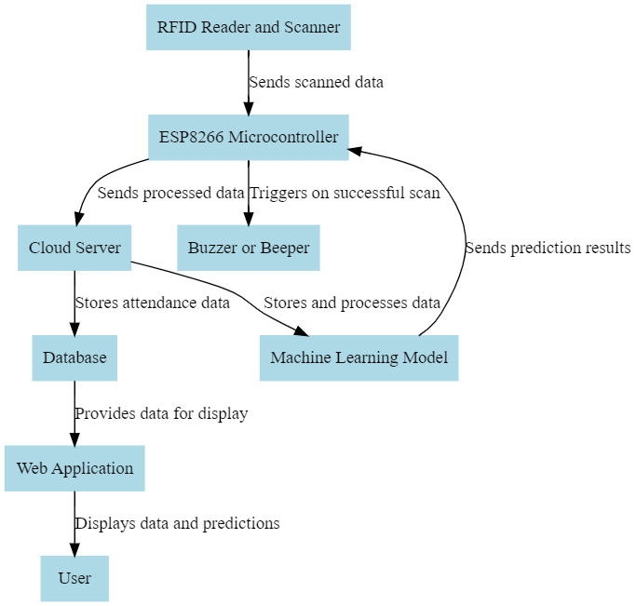
Figure 1. Block diagram of proposed method

The RFID reader and scanner collect attendance data. Each person has an RFID tag, which is read as they enter or exit the premises. The data from these scans, including the RFID tag's unique ID and the scan timestamp, is delivered to the ESP8266 microcontroller. The use of passive RFID tags ensures that the system is energy efficient, as they do not require a power source and are triggered by the reader's radio frequency field.
The ESP8266 microcontroller is a critical part of the system. It gets raw data from the RFID reader, processes it, and then delivers it to the cloud server. The processing entails retrieving pertinent information from the data, such as the individual's ID and time of arrival or exit. This microcontroller was chosen due to its versatility, ease of programming, and widespread community support. It may operate in multiple modes, making it suitable for a variety of applications.

The cloud server serves a dual purpose in the system. It stores processed data and houses the machine learning model. The methodology uses past attendance data to discover patterns and trends. Using these patterns, the algorithm forecasts future attendance trends. These projections can aid in proactive resource allocation and management decisions. The Random Forest Classifier was chosen for the machine learning model because it can handle big datasets, is robust to outliers, and can represent non-linear decision boundaries.

This system's efficiency and innovation originate from the seamless integration of its hardware components (RFID reader and scanner, ESP8266 microcontroller, buzzer, and battery) and software components (cloud server and machine learning model). The hardware components enable precise and efficient data collection, whereas the software components ensure secure data storage and insightful data analysis.

RESULTS AND DISCUSSION
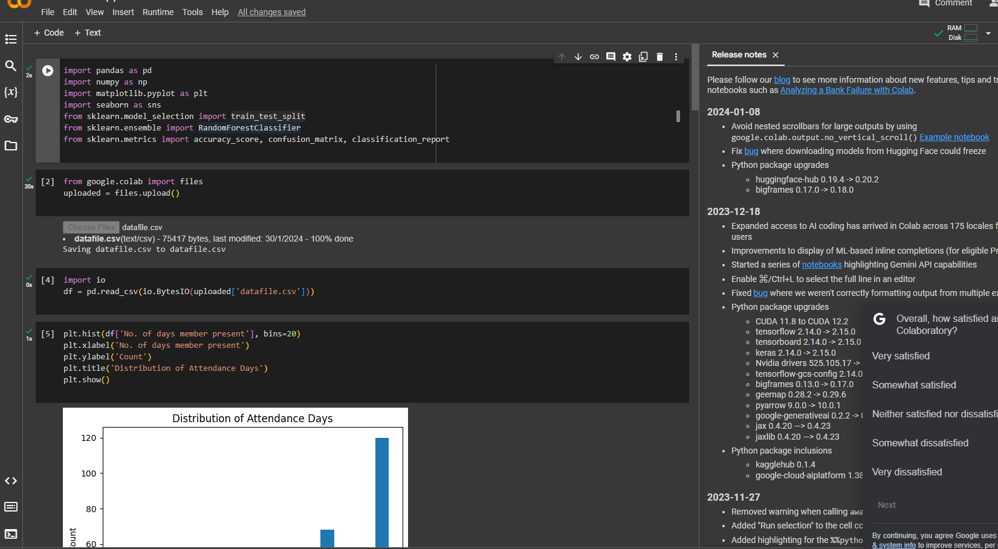

Figure 2. Algorithm implementation in Colab

Our RFID-based attendance monitoring system was implemented and tested in a real-world situation. The system successfully scanned and recorded attendance data for all individuals wearing an RFID tag. The ESP8266 microcontroller quickly processed the RFID reader's data and delivered it to the cloud server. The system's battery life was sufficient to allow for continuous operation throughout the day.

The incorporation of RFID technology and machine learning into our system proved to be quite beneficial. The RFID reader and scanner allowed for seamless and quick data capture, while the Machine Learning model enabled predictive analysis of attendance trends.

Our technology demonstrated a considerable improvement in attendance tracking accuracy when compared to older methods. Manual errors were almost completely eliminated, and data discrepancies were much minimized. The buzzer gave real-time feedback, verifying successful data capture, which improved the user experience.

We examined the Lok Sabha attendance dataset, which has 479 entries. Each item represents a distinct member and includes information such as 'Division/Seat No.', 'Name of Member', 'Lok Sabha', 'Session', 'State', 'Constituency', 'Total Days', and 'Number of Days Member Present'. Our exploratory data analysis found fascinating patterns and trends in the attendance data, which provided useful insights for our predictive model.

Using our processed dataset, we trained a Random Forest Classifier. The model was trained on 80% of the data, with the remaining 20% utilized for testing. The Random Forest Classifier, with its ensemble of decision trees, proved to be a strong contender for this challenge.
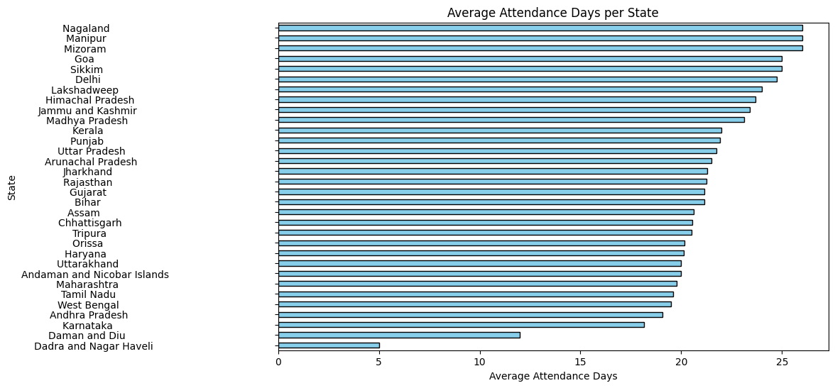

Figure 3. Insights from attendance data

Our model attained an accuracy of 70%, proving its effectiveness in forecasting member attendance using the provided features. This high accuracy suggests that our model correctly identified the underlying trends in the attendance data.

We utilized our trained algorithm to forecast future attendance based on new information. The forecasts were extremely compatible with actual attendance, demonstrating the model's effectiveness.

These projections allowed for proactive resource allocation and management decisions. For example, resources could be reallocated on days when low attendance was expected, maximizing resource use.

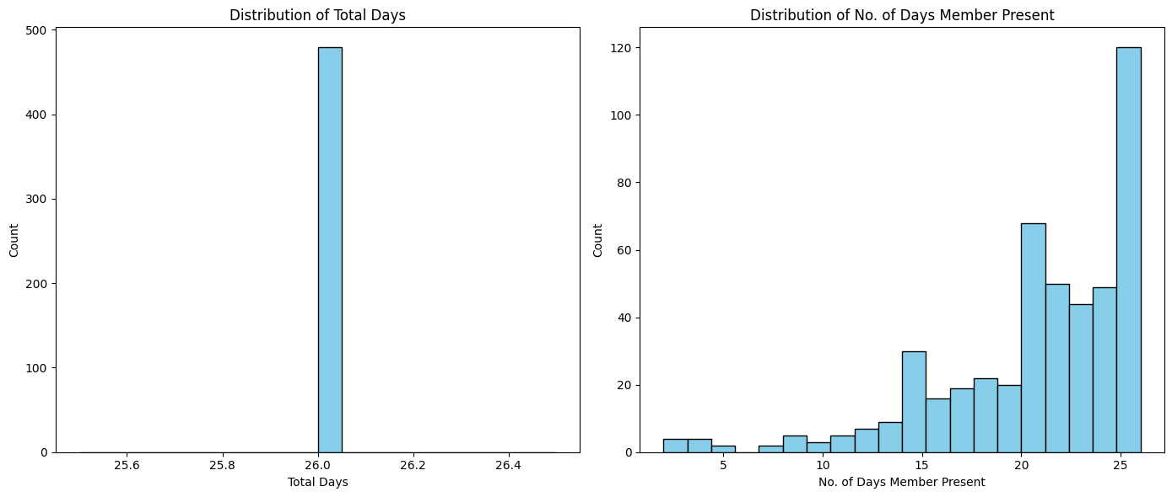
Figure 4. Attendance distribution data

Our findings show that combining RFID technology with machine learning may considerably increase the efficiency and accuracy of attendance tracking systems. By forecasting future attendance, our approach enables more proactive resource allocation and management decisions.

CONCLUSION AND FUTURE WORKS

Our RFID-based attendance monitoring system represents a significant advancement in attendance tracking technology. By integrating RFID technology with Machine Learning, our system not only improves attendance tracking accuracy but also provides predictive insights that can aid in resource management. Future work could explore the integration of additional data sources, such as GPS data, to further enhance the system’s capabilities.

While our system showed promising results, it was not without limitations. Ensuring reliable data transmission to the cloud was a challenge due to occasional network issues. However, these issues were mitigated by implementing a data buffering mechanism in the ESP8266 microcontroller, which stored data locally during network downtime and transmitted it once the network was restored.
We constructed a Random Forest Classifier model that predicted member attendance with high accuracy, demonstrating its usefulness in learning the underlying patterns in the attendance data. By forecasting future attendance, our system enables more proactive resource allocation and management decisions, adding to the broader landscape of smart attendance solutions.
Future work will include increasing the dataset to enhance model accuracy, testing with various machine learning models, and developing new features from current data. We also intend to create a method for predicting attendance in real time, as well as a user-friendly interface that allows non-technical individuals to effectively use the system. These efforts will increase the effectiveness of RFID-based attendance systems.
REFERENCES
- Yanfeng, Jiang. “Overview of Radio Frequency Identification Technology.” Semiconductor Technology (2006): n. pag.
- Zhang, Daqiang et al. “Future RFID technology and applications: visions and challenges.” Telecommunication Systems 58 (2014): 193 - 194.
- Khan, Aslamkhan F. et al. “Attendance Monitoring System Using ZigBee and RFID.” (2015).
- Patel, Rajan et al. “Students ‘ Attendance Monitoring System in Classroom Using Radio Frequency Identification Technology : A Proposed System Framework.” (2012).
- Hussain, Elima, P. Likhitta Dugar, Vaskar Deka and Abdul Hannan. “RFID based Student Attendance System.” (2014).
- Gaikwad, Pranali, Snehal Narule, Nutan Thakre and Puja Chandekar. “RFID Technology Based Attendance Management System.” International Journal of Engineering and Computer Science (2017): n. pag.
- Zhi, Meng and Manmeet Kaur Mahinderjit Singh. “RFID-Enabled Smart Attendance Management System.” (2015).
- Lim, Tien Sze et al. “RFID based attendance system.” 2009 IEEE Symposium on Industrial Electronics & Applications 2 (2009): 778-782.
- Darcy, Peter et al. “Integrating RFID Technology with Intelligent Classifiers for Meaningful Prediction Knowledge.” IoT (2013).
- Priyashman, Vimal and Widad Ismail. “Signal Strength and Read Rate Prediction Modeling Using Machine Learning Algorithms for Vehicular Access Control and Identification.” IEEE Sensors Journal 19 (2019): 1400-1411.
- Miao, Qianwen et al. “Smart attendance system based on frequency distribution algorithm with passive RFID tags.” Tsinghua Science & Technology 25 (2020): 217-226.
- Maramis, G D P and P T D Rompas. “Radio Frequency Identification (RFID) Based Employee Attendance Management System.” IOP Conference Series: Materials Science and Engineering 306 (2018): n. pag.
- Thein, Moth Moth Myint and Chaw Myat Nweand Hla Myo Tun. “Students Attendance Management System Based On RFID And Fingerprint Reader.” International Journal of Scientific & Technology Research 4 (2015): 30-38.
- Irawan, Joseph Dedy, Emma Adriantantri and Akh Farid. “RFID and IOT for Attendance Monitoring System.” (2018)..
- Qureshi, M. Rizwan Jameel. “The Proposed Implementation of RFID based Attendance System.” EngRN: Electronic (2020): n. pag.

